UNITED STATES
SECURITIES AND EXCHANGE COMMISSION
Washington, D.C. 20549

FORM 6-K

REPORT OF FOREIGN PRIVATE ISSUER
PURSUANT TO RULE 13a-16 OR 15d-16 UNDER
THE SECURITIES EXCHANGE ACT OF 1934

For the month of September 2026

Commission File Number: 001-39436

KE Holdings Inc.
(Registrant’s Name)

Oriental Electronic Technology Building,
No. 2 Chuangye Road, Haidian District,
Beijing 100086
People’s Republic of China
(Address of Principal Executive Offices)

Indicate by check mark whether the registrant files or will file annual reports under cover Form 20-F or Form 40-F.

Form 20-F ☒ Form 40-F ☐

EXHIBIT INDEX

Exhibit No. |  | Description
99.1 |  | Next Day Disclosure Return Dated August 31, 2026
99.2 |  | Next Day Disclosure Return Dated September 1, 2026
99.3 |  | Next Day Disclosure Return Dated September 2, 2026
99.4 |  | Next Day Disclosure Return Dated September 3, 2026
99.5 |  | Monthly Return for Equity Issuer on Movements in Securities
99.6 |  | Next Day Disclosure Return Dated September 4, 2026

SIGNATURES

Pursuant to the requirements of the Securities Exchange Act of 1934, the registrant has duly caused this report to be signed on its behalf by the undersigned, thereunto duly authorized.

 | KE Holdings Inc.
 | By | : | /s/ XU Tao
 | Name | : | XU Tao
 | Title | : | Chief Financial Officer

Date: September 8, 2026

Exhibit 99.1
 | 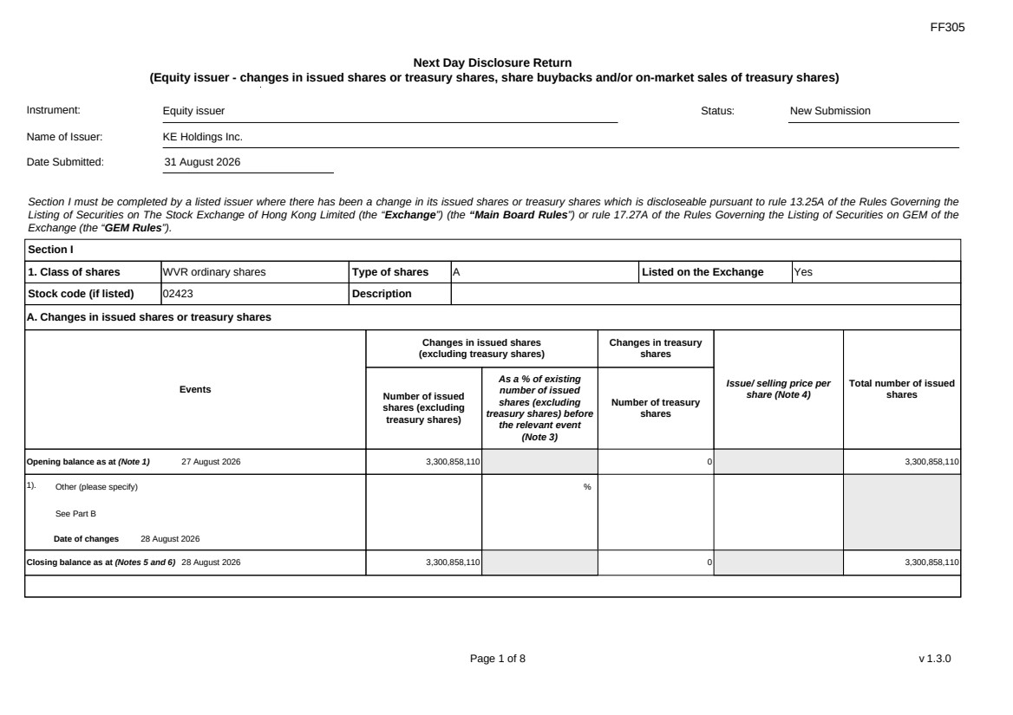 | FF305 Page 1 of 8 v 1.3.0 Next Day Disclosure Return (Equity issuer - changes in issued shares or treasury shares, share buybacks and/or on-market sales of treasury shares) Instrument: Equity issuer Status: New Submission Name of Issuer: KE Holdings Inc. Date Submitted: 31 August 2026 Section I must be completed by a listed issuer where there has been a change in its issued shares or treasury shares which is discloseable pursuant to rule 13.25A of the Rules Governing the Listing of Securities on The Stock Exchange of Hong Kong Limited (the “Exchange”) (the “Main Board Rules”) or rule 17.27A of the Rules Governing the Listing of Securities on GEM of the Exchange (the “GEM Rules”). Section I 1. Class of shares WVR ordinary shares Type of shares A Listed on the Exchange Yes Stock code (if listed) 02423 Description A. Changes in issued shares or treasury shares Events Changes in issued shares (excluding treasury shares) Number of issued shares (excluding treasury shares) As a % of existing number of issued shares (excluding treasury shares) before the relevant event (Note 3) Changes in treasury shares Number of treasury shares Issue/ selling price per share (Note 4) Total number of issued shares Opening balance as at (Note 1) 27 August 2026 3,300,858,110 0 3,300,858,110 1). Other (please specify) See Part B Date of changes 28 August 2026 % Closing balance as at (Notes 5 and 6) 28 August 2026 3,300,858,110 0 3,300,858,110
 | 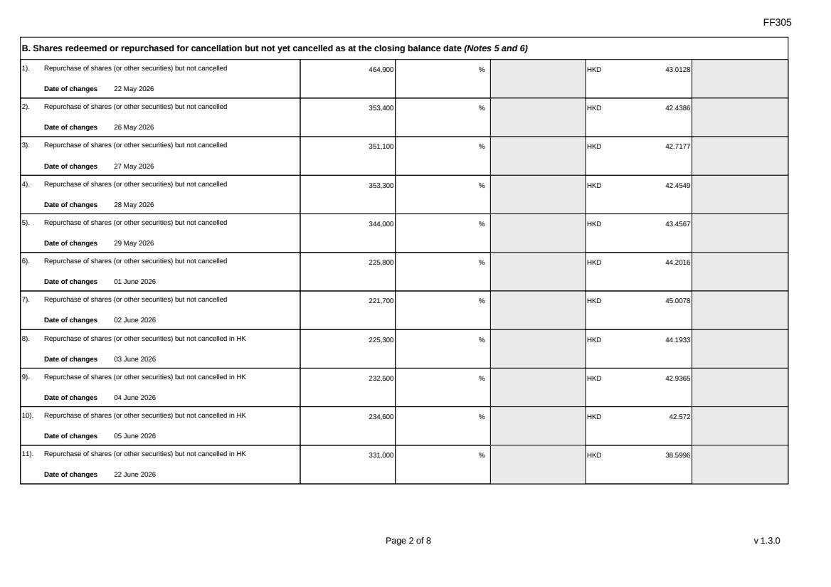 | FF305 Page 2 of 8 v 1.3.0 B. Shares redeemed or repurchased for cancellation but not yet cancelled as at the closing balance date (Notes 5 and 6) 1). Repurchase of shares (or other securities) but not cancelled Date of changes 22 May 2026 464,900 % HKD 43.0128 2). Repurchase of shares (or other securities) but not cancelled Date of changes 26 May 2026 353,400 % HKD 42.4386 3). Repurchase of shares (or other securities) but not cancelled Date of changes 27 May 2026 351,100 % HKD 42.7177 4). Repurchase of shares (or other securities) but not cancelled Date of changes 28 May 2026 353,300 % HKD 42.4549 5). Repurchase of shares (or other securities) but not cancelled Date of changes 29 May 2026 344,000 % HKD 43.4567 6). Repurchase of shares (or other securities) but not cancelled Date of changes 01 June 2026 225,800 % HKD 44.2016 7). Repurchase of shares (or other securities) but not cancelled Date of changes 02 June 2026 221,700 % HKD 45.0078 8). Repurchase of shares (or other securities) but not cancelled in HK Date of changes 03 June 2026 225,300 % HKD 44.1933 9). Repurchase of shares (or other securities) but not cancelled in HK Date of changes 04 June 2026 232,500 % HKD 42.9365 10). Repurchase of shares (or other securities) but not cancelled in HK Date of changes 05 June 2026 234,600 % HKD 42.572 11). Repurchase of shares (or other securities) but not cancelled in HK Date of changes 22 June 2026 331,000 % HKD 38.5996
 | 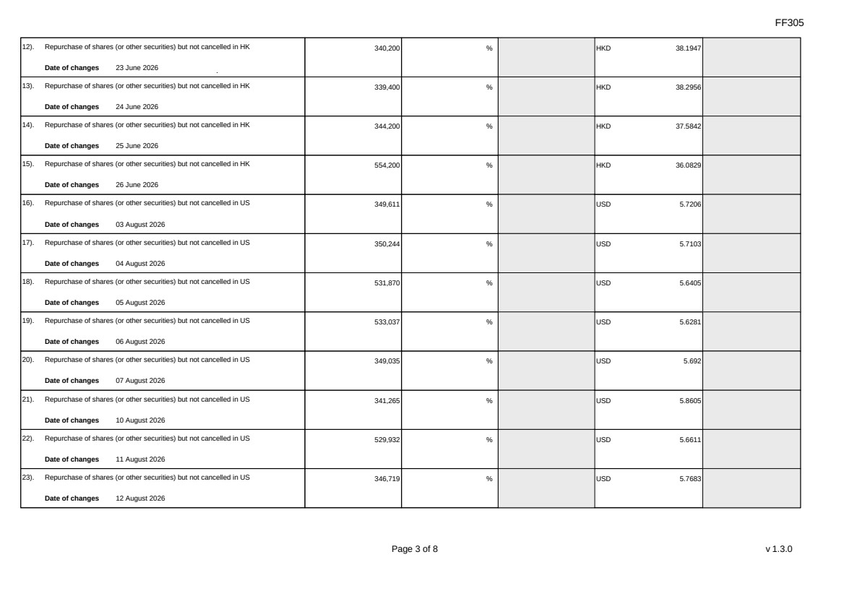 | FF305 Page 3 of 8 v 1.3.0 12). Repurchase of shares (or other securities) but not cancelled in HK Date of changes 23 June 2026 340,200 % HKD 38.1947 13). Repurchase of shares (or other securities) but not cancelled in HK Date of changes 24 June 2026 339,400 % HKD 38.2956 14). Repurchase of shares (or other securities) but not cancelled in HK Date of changes 25 June 2026 344,200 % HKD 37.5842 15). Repurchase of shares (or other securities) but not cancelled in HK Date of changes 26 June 2026 554,200 % HKD 36.0829 16). Repurchase of shares (or other securities) but not cancelled in US Date of changes 03 August 2026 349,611 % USD 5.7206 17). Repurchase of shares (or other securities) but not cancelled in US Date of changes 04 August 2026 350,244 % USD 5.7103 18). Repurchase of shares (or other securities) but not cancelled in US Date of changes 05 August 2026 531,870 % USD 5.6405 19). Repurchase of shares (or other securities) but not cancelled in US Date of changes 06 August 2026 533,037 % USD 5.6281 20). Repurchase of shares (or other securities) but not cancelled in US Date of changes 07 August 2026 349,035 % USD 5.692 21). Repurchase of shares (or other securities) but not cancelled in US Date of changes 10 August 2026 341,265 % USD 5.8605 22). Repurchase of shares (or other securities) but not cancelled in US Date of changes 11 August 2026 529,932 % USD 5.6611 23). Repurchase of shares (or other securities) but not cancelled in US Date of changes 12 August 2026 346,719 % USD 5.7683
 | 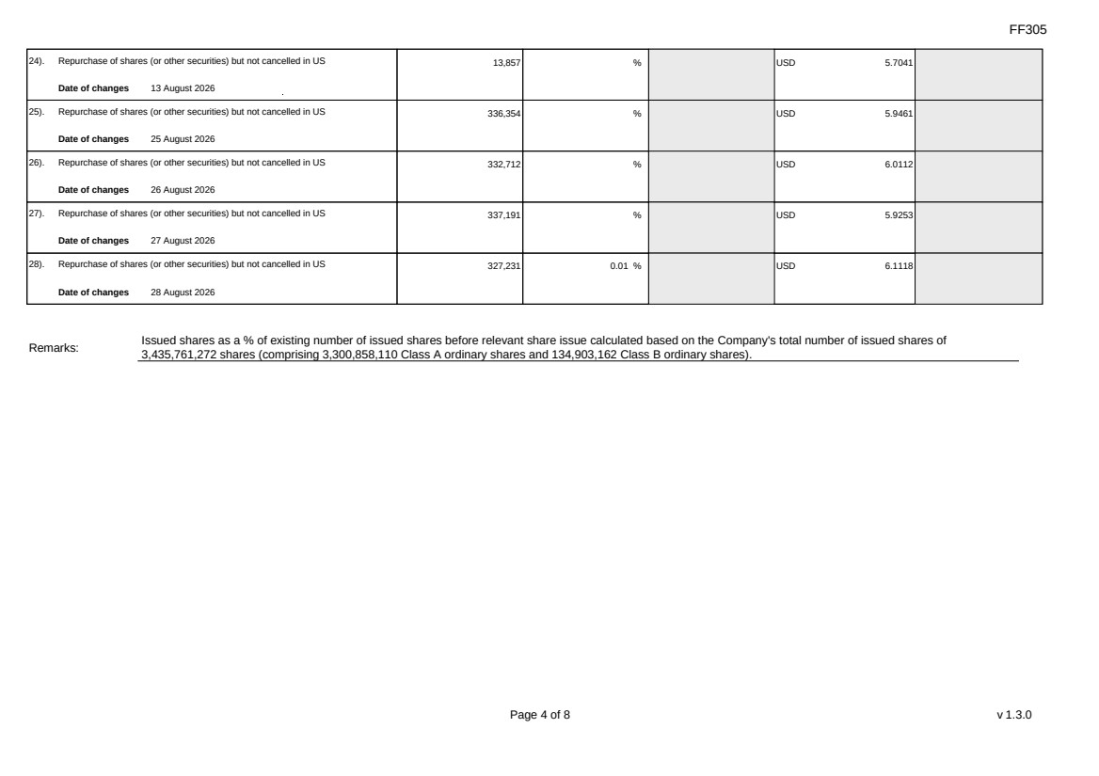 | FF305 Page 4 of 8 v 1.3.0 24). Repurchase of shares (or other securities) but not cancelled in US Date of changes 13 August 2026 13,857 % USD 5.7041 25). Repurchase of shares (or other securities) but not cancelled in US Date of changes 25 August 2026 336,354 % USD 5.9461 26). Repurchase of shares (or other securities) but not cancelled in US Date of changes 26 August 2026 332,712 % USD 6.0112 27). Repurchase of shares (or other securities) but not cancelled in US Date of changes 27 August 2026 337,191 % USD 5.9253 28). Repurchase of shares (or other securities) but not cancelled in US Date of changes 28 August 2026 327,231 0.01 % USD 6.1118 Remarks: Issued shares as a % of existing number of issued shares before relevant share issue calculated based on the Company's total number of issued shares of 3,435,761,272 shares (comprising 3,300,858,110 Class A ordinary shares and 134,903,162 Class B ordinary shares).
 | 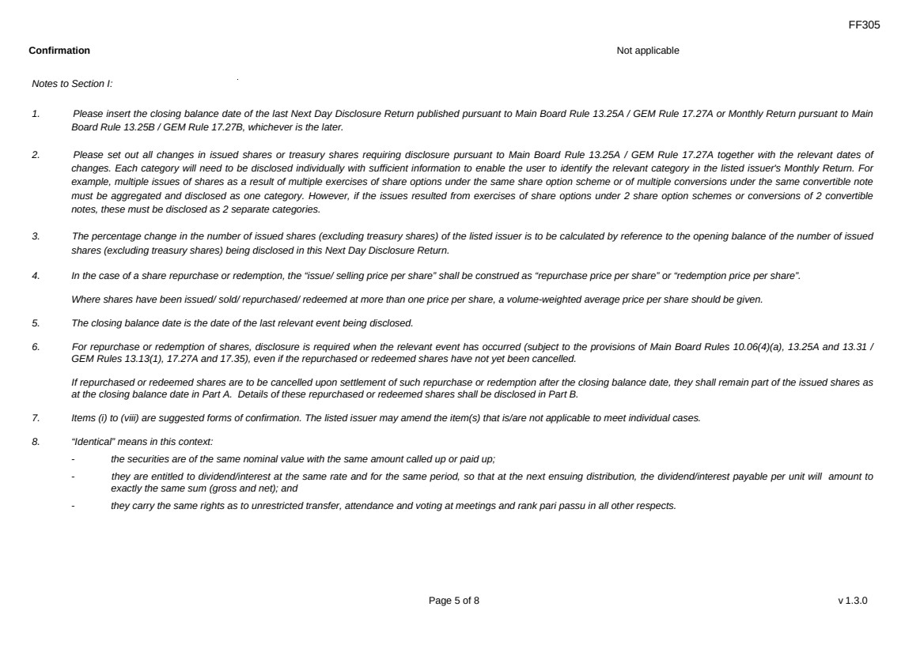 | FF305 Page 5 of 8 v 1.3.0 Confirmation Not applicable Notes to Section I: 1. Please insert the closing balance date of the last Next Day Disclosure Return published pursuant to Main Board Rule 13.25A / GEM Rule 17.27A or Monthly Return pursuant to Main Board Rule 13.25B / GEM Rule 17.27B, whichever is the later. 2. Please set out all changes in issued shares or treasury shares requiring disclosure pursuant to Main Board Rule 13.25A / GEM Rule 17.27A together with the relevant dates of changes. Each category will need to be disclosed individually with sufficient information to enable the user to identify the relevant category in the listed issuer's Monthly Return. For example, multiple issues of shares as a result of multiple exercises of share options under the same share option scheme or of multiple conversions under the same convertible note must be aggregated and disclosed as one category. However, if the issues resulted from exercises of share options under 2 share option schemes or conversions of 2 convertible notes, these must be disclosed as 2 separate categories. 3. The percentage change in the number of issued shares (excluding treasury shares) of the listed issuer is to be calculated by reference to the opening balance of the number of issued shares (excluding treasury shares) being disclosed in this Next Day Disclosure Return. 4. In the case of a share repurchase or redemption, the “issue/ selling price per share” shall be construed as “repurchase price per share” or “redemption price per share”. Where shares have been issued/ sold/ repurchased/ redeemed at more than one price per share, a volume-weighted average price per share should be given. 5. The closing balance date is the date of the last relevant event being disclosed. 6. For repurchase or redemption of shares, disclosure is required when the relevant event has occurred (subject to the provisions of Main Board Rules 10.06(4)(a), 13.25A and 13.31 / GEM Rules 13.13(1), 17.27A and 17.35), even if the repurchased or redeemed shares have not yet been cancelled. If repurchased or redeemed shares are to be cancelled upon settlement of such repurchase or redemption after the closing balance date, they shall remain part of the issued shares as at the closing balance date in Part A. Details of these repurchased or redeemed shares shall be disclosed in Part B. 7. Items (i) to (viii) are suggested forms of confirmation. The listed issuer may amend the item(s) that is/are not applicable to meet individual cases. 8. “Identical” means in this context: - the securities are of the same nominal value with the same amount called up or paid up; - they are entitled to dividend/interest at the same rate and for the same period, so that at the next ensuing distribution, the dividend/interest payable per unit will amount to exactly the same sum (gross and net); and - they carry the same rights as to unrestricted transfer, attendance and voting at meetings and rank pari passu in all other respects.
 | 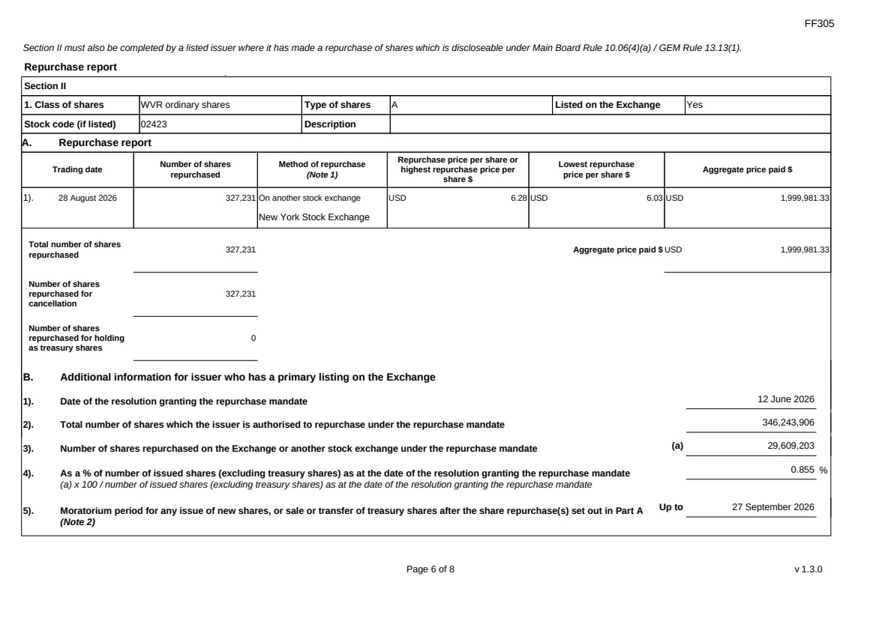 | FF305 Page 6 of 8 v 1.3.0 Section II must also be completed by a listed issuer where it has made a repurchase of shares which is discloseable under Main Board Rule 10.06(4)(a) / GEM Rule 13.13(1). Repurchase report Section II 1. Class of shares WVR ordinary shares Type of shares A Listed on the Exchange Yes Stock code (if listed) 02423 Description A. Repurchase report Trading date Number of shares repurchased Method of repurchase (Note 1) Repurchase price per share or highest repurchase price per share $ Lowest repurchase price per share $ Aggregate price paid $ 1). 28 August 2026 327,231 On another stock exchange New York Stock Exchange USD 6.28 USD 6.03 USD 1,999,981.33 Total number of shares repurchased 327,231 Aggregate price paid $ USD 1,999,981.33 Number of shares repurchased for cancellation 327,231 Number of shares repurchased for holding as treasury shares 0 B. Additional information for issuer who has a primary listing on the Exchange 1). Date of the resolution granting the repurchase mandate 12 June 2026 2). Total number of shares which the issuer is authorised to repurchase under the repurchase mandate 346,243,906 3). Number of shares repurchased on the Exchange or another stock exchange under the repurchase mandate (a) 29,609,203 4). As a % of number of issued shares (excluding treasury shares) as at the date of the resolution granting the repurchase mandate (a) x 100 / number of issued shares (excluding treasury shares) as at the date of the resolution granting the repurchase mandate 0.855 % 5). Moratorium period for any issue of new shares, or sale or transfer of treasury shares after the share repurchase(s) set out in Part A (Note 2) Up to 27 September 2026
 | 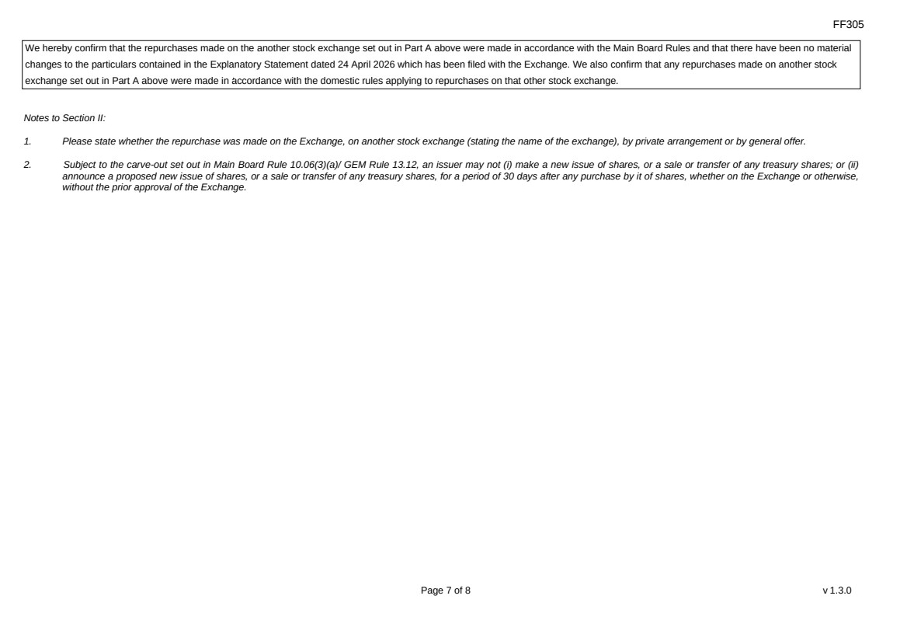 | FF305 Page 7 of 8 v 1.3.0 We hereby confirm that the repurchases made on the another stock exchange set out in Part A above were made in accordance with the Main Board Rules and that there have been no material changes to the particulars contained in the Explanatory Statement dated 24 April 2026 which has been filed with the Exchange. We also confirm that any repurchases made on another stock exchange set out in Part A above were made in accordance with the domestic rules applying to repurchases on that other stock exchange. Notes to Section II: 1. Please state whether the repurchase was made on the Exchange, on another stock exchange (stating the name of the exchange), by private arrangement or by general offer. 2. Subject to the carve-out set out in Main Board Rule 10.06(3)(a)/ GEM Rule 13.12, an issuer may not (i) make a new issue of shares, or a sale or transfer of any treasury shares; or (ii) announce a proposed new issue of shares, or a sale or transfer of any treasury shares, for a period of 30 days after any purchase by it of shares, whether on the Exchange or otherwise, without the prior approval of the Exchange.
 | 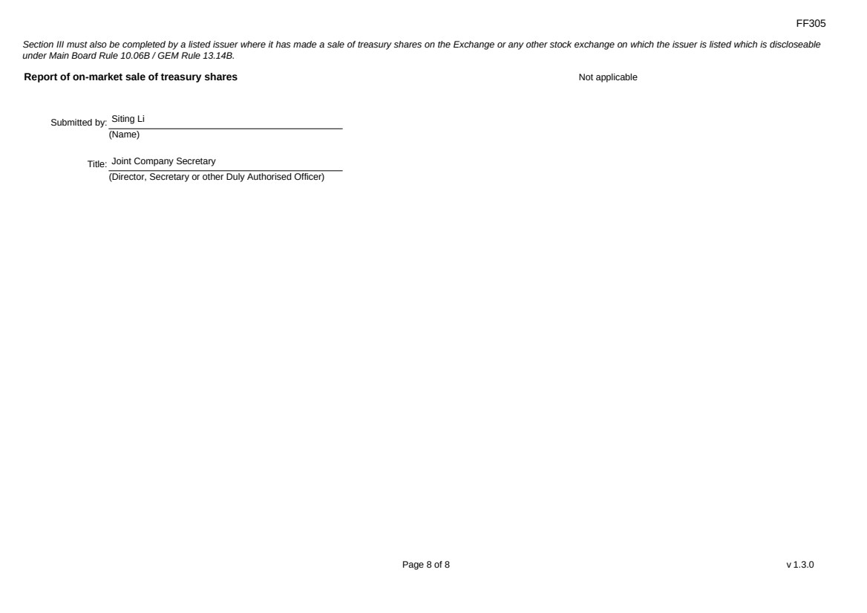 | FF305 Page 8 of 8 v 1.3.0 Section III must also be completed by a listed issuer where it has made a sale of treasury shares on the Exchange or any other stock exchange on which the issuer is listed which is discloseable under Main Board Rule 10.06B / GEM Rule 13.14B. Report of on-market sale of treasury shares Not applicable Submitted by: Siting Li (Name) Title: Joint Company Secretary (Director, Secretary or other Duly Authorised Officer)

Exhibit 99.2
 | 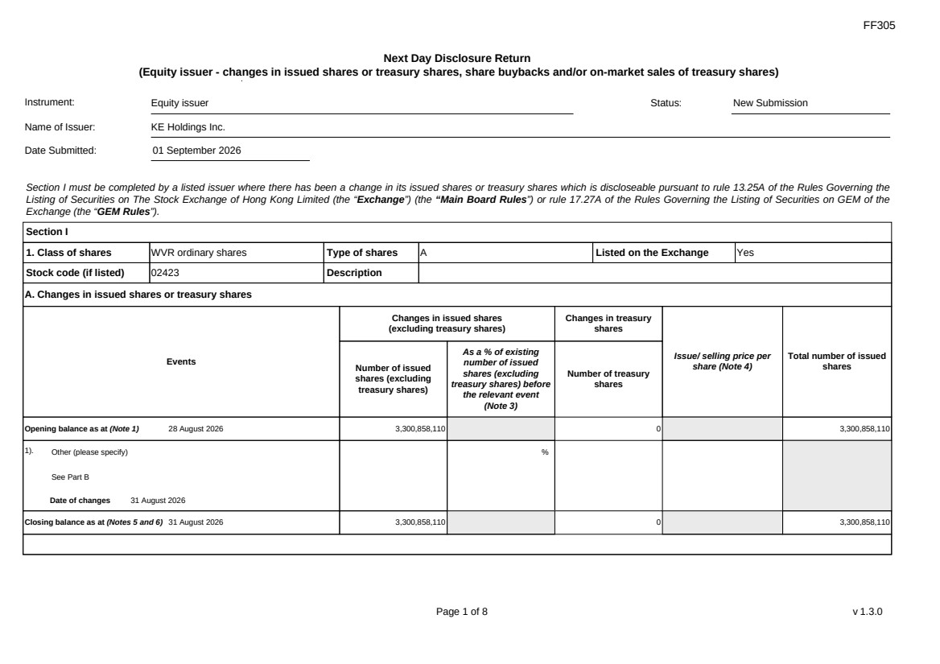 | FF305 Page 1 of 8 v 1.3.0 Next Day Disclosure Return (Equity issuer - changes in issued shares or treasury shares, share buybacks and/or on-market sales of treasury shares) Instrument: Equity issuer Status: New Submission Name of Issuer: KE Holdings Inc. Date Submitted: 01 September 2026 Section I must be completed by a listed issuer where there has been a change in its issued shares or treasury shares which is discloseable pursuant to rule 13.25A of the Rules Governing the Listing of Securities on The Stock Exchange of Hong Kong Limited (the “Exchange”) (the “Main Board Rules”) or rule 17.27A of the Rules Governing the Listing of Securities on GEM of the Exchange (the “GEM Rules”). Section I 1. Class of shares WVR ordinary shares Type of shares A Listed on the Exchange Yes Stock code (if listed) 02423 Description A. Changes in issued shares or treasury shares Events Changes in issued shares (excluding treasury shares) Number of issued shares (excluding treasury shares) As a % of existing number of issued shares (excluding treasury shares) before the relevant event (Note 3) Changes in treasury shares Number of treasury shares Issue/ selling price per share (Note 4) Total number of issued shares Opening balance as at (Note 1) 28 August 2026 3,300,858,110 0 3,300,858,110 1). Other (please specify) See Part B Date of changes 31 August 2026 % Closing balance as at (Notes 5 and 6) 31 August 2026 3,300,858,110 0 3,300,858,110
FF305 Page 2 of 8 v 1.3.0 B. Shares redeemed or repurchased for cancellation but not yet cancelled as at the closing balance date (Notes 5 and 6) 1). Repurchase of shares (or other securities) but not cancelled Date of changes 22 May 2026 464,900 % HKD 43.0128 2). Repurchase of shares (or other securities) but not cancelled Date of changes 26 May 2026 353,400 % HKD 42.4386 3). Repurchase of shares (or other securities) but not cancelled Date of changes 27 May 2026 351,100 % HKD 42.7177 4). Repurchase of shares (or other securities) but not cancelled Date of changes 28 May 2026 353,300 % HKD 42.4549 5). Repurchase of shares (or other securities) but not cancelled Date of changes 29 May 2026 344,000 % HKD 43.4567 6). Repurchase of shares (or other securities) but not cancelled Date of changes 01 June 2026 225,800 % HKD 44.2016 7). Repurchase of shares (or other securities) but not cancelled Date of changes 02 June 2026 221,700 % HKD 45.0078 8). Repurchase of shares (or other securities) but not cancelled in HK Date of changes 03 June 2026 225,300 % HKD 44.1933 9). Repurchase of shares (or other securities) but not cancelled in HK Date of changes 04 June 2026 232,500 % HKD 42.9365 10). Repurchase of shares (or other securities) but not cancelled in HK Date of changes 05 June 2026 234,600 % HKD 42.572 11). Repurchase of shares (or other securities) but not cancelled in HK Date of changes 22 June 2026 331,000 % HKD 38.5996
FF305 Page 3 of 8 v 1.3.0 12). Repurchase of shares (or other securities) but not cancelled in HK Date of changes 23 June 2026 340,200 % HKD 38.1947 13). Repurchase of shares (or other securities) but not cancelled in HK Date of changes 24 June 2026 339,400 % HKD 38.2956 14). Repurchase of shares (or other securities) but not cancelled in HK Date of changes 25 June 2026 344,200 % HKD 37.5842 15). Repurchase of shares (or other securities) but not cancelled in HK Date of changes 26 June 2026 554,200 % HKD 36.0829 16). Repurchase of shares (or other securities) but not cancelled in US Date of changes 03 August 2026 349,611 % USD 5.7206 17). Repurchase of shares (or other securities) but not cancelled in US Date of changes 04 August 2026 350,244 % USD 5.7103 18). Repurchase of shares (or other securities) but not cancelled in US Date of changes 05 August 2026 531,870 % USD 5.6405 19). Repurchase of shares (or other securities) but not cancelled in US Date of changes 06 August 2026 533,037 % USD 5.6281 20). Repurchase of shares (or other securities) but not cancelled in US Date of changes 07 August 2026 349,035 % USD 5.692 21). Repurchase of shares (or other securities) but not cancelled in US Date of changes 10 August 2026 341,265 % USD 5.8605 22). Repurchase of shares (or other securities) but not cancelled in US Date of changes 11 August 2026 529,932 % USD 5.6611 23). Repurchase of shares (or other securities) but not cancelled in US Date of changes 12 August 2026 346,719 % USD 5.7683
 | 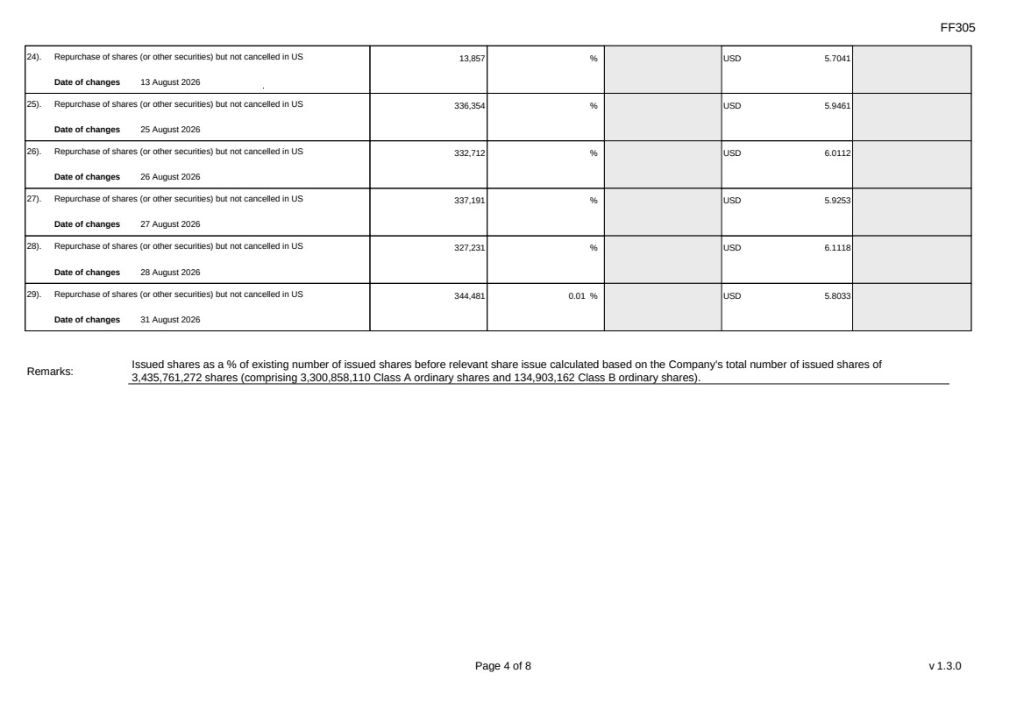 | FF305 Page 4 of 8 v 1.3.0 24). Repurchase of shares (or other securities) but not cancelled in US Date of changes 13 August 2026 13,857 % USD 5.7041 25). Repurchase of shares (or other securities) but not cancelled in US Date of changes 25 August 2026 336,354 % USD 5.9461 26). Repurchase of shares (or other securities) but not cancelled in US Date of changes 26 August 2026 332,712 % USD 6.0112 27). Repurchase of shares (or other securities) but not cancelled in US Date of changes 27 August 2026 337,191 % USD 5.9253 28). Repurchase of shares (or other securities) but not cancelled in US Date of changes 28 August 2026 327,231 % USD 6.1118 29). Repurchase of shares (or other securities) but not cancelled in US Date of changes 31 August 2026 344,481 0.01 % USD 5.8033 Remarks: Issued shares as a % of existing number of issued shares before relevant share issue calculated based on the Company's total number of issued shares of 3,435,761,272 shares (comprising 3,300,858,110 Class A ordinary shares and 134,903,162 Class B ordinary shares).
FF305 Page 5 of 8 v 1.3.0 Confirmation Not applicable Notes to Section I: 1. Please insert the closing balance date of the last Next Day Disclosure Return published pursuant to Main Board Rule 13.25A / GEM Rule 17.27A or Monthly Return pursuant to Main Board Rule 13.25B / GEM Rule 17.27B, whichever is the later. 2. Please set out all changes in issued shares or treasury shares requiring disclosure pursuant to Main Board Rule 13.25A / GEM Rule 17.27A together with the relevant dates of changes. Each category will need to be disclosed individually with sufficient information to enable the user to identify the relevant category in the listed issuer's Monthly Return. For example, multiple issues of shares as a result of multiple exercises of share options under the same share option scheme or of multiple conversions under the same convertible note must be aggregated and disclosed as one category. However, if the issues resulted from exercises of share options under 2 share option schemes or conversions of 2 convertible notes, these must be disclosed as 2 separate categories. 3. The percentage change in the number of issued shares (excluding treasury shares) of the listed issuer is to be calculated by reference to the opening balance of the number of issued shares (excluding treasury shares) being disclosed in this Next Day Disclosure Return. 4. In the case of a share repurchase or redemption, the “issue/ selling price per share” shall be construed as “repurchase price per share” or “redemption price per share”. Where shares have been issued/ sold/ repurchased/ redeemed at more than one price per share, a volume-weighted average price per share should be given. 5. The closing balance date is the date of the last relevant event being disclosed. 6. For repurchase or redemption of shares, disclosure is required when the relevant event has occurred (subject to the provisions of Main Board Rules 10.06(4)(a), 13.25A and 13.31 / GEM Rules 13.13(1), 17.27A and 17.35), even if the repurchased or redeemed shares have not yet been cancelled. If repurchased or redeemed shares are to be cancelled upon settlement of such repurchase or redemption after the closing balance date, they shall remain part of the issued shares as at the closing balance date in Part A. Details of these repurchased or redeemed shares shall be disclosed in Part B. 7. Items (i) to (viii) are suggested forms of confirmation. The listed issuer may amend the item(s) that is/are not applicable to meet individual cases. 8. “Identical” means in this context: - the securities are of the same nominal value with the same amount called up or paid up; - they are entitled to dividend/interest at the same rate and for the same period, so that at the next ensuing distribution, the dividend/interest payable per unit will amount to exactly the same sum (gross and net); and - they carry the same rights as to unrestricted transfer, attendance and voting at meetings and rank pari passu in all other respects.
 | 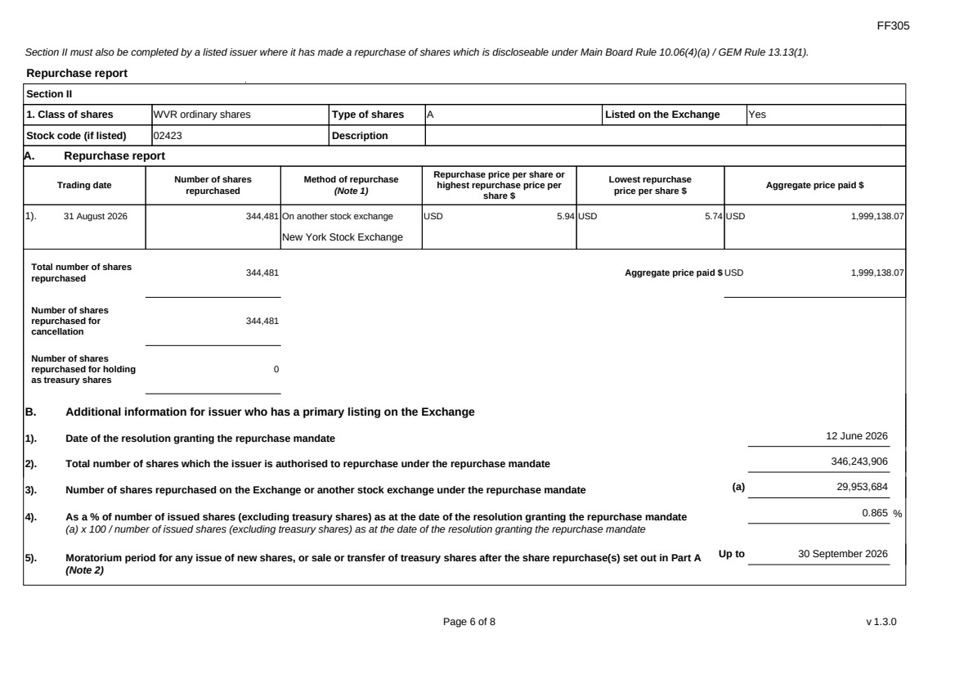 | FF305 Page 6 of 8 v 1.3.0 Section II must also be completed by a listed issuer where it has made a repurchase of shares which is discloseable under Main Board Rule 10.06(4)(a) / GEM Rule 13.13(1). Repurchase report Section II 1. Class of shares WVR ordinary shares Type of shares A Listed on the Exchange Yes Stock code (if listed) 02423 Description A. Repurchase report Trading date Number of shares repurchased Method of repurchase (Note 1) Repurchase price per share or highest repurchase price per share $ Lowest repurchase price per share $ Aggregate price paid $ 1). 31 August 2026 344,481 On another stock exchange New York Stock Exchange USD 5.94 USD 5.74 USD 1,999,138.07 Total number of shares repurchased 344,481 Aggregate price paid $ USD 1,999,138.07 Number of shares repurchased for cancellation 344,481 Number of shares repurchased for holding as treasury shares 0 B. Additional information for issuer who has a primary listing on the Exchange 1). Date of the resolution granting the repurchase mandate 12 June 2026 2). Total number of shares which the issuer is authorised to repurchase under the repurchase mandate 346,243,906 3). Number of shares repurchased on the Exchange or another stock exchange under the repurchase mandate (a) 29,953,684 4). As a % of number of issued shares (excluding treasury shares) as at the date of the resolution granting the repurchase mandate (a) x 100 / number of issued shares (excluding treasury shares) as at the date of the resolution granting the repurchase mandate 0.865 % 5). Moratorium period for any issue of new shares, or sale or transfer of treasury shares after the share repurchase(s) set out in Part A (Note 2) Up to 30 September 2026
FF305 Page 7 of 8 v 1.3.0 We hereby confirm that the repurchases made on the another stock exchange set out in Part A above were made in accordance with the Main Board Rules and that there have been no material changes to the particulars contained in the Explanatory Statement dated 24 April 2026 which has been filed with the Exchange. We also confirm that any repurchases made on another stock exchange set out in Part A above were made in accordance with the domestic rules applying to repurchases on that other stock exchange. Notes to Section II: 1. Please state whether the repurchase was made on the Exchange, on another stock exchange (stating the name of the exchange), by private arrangement or by general offer. 2. Subject to the carve-out set out in Main Board Rule 10.06(3)(a)/ GEM Rule 13.12, an issuer may not (i) make a new issue of shares, or a sale or transfer of any treasury shares; or (ii) announce a proposed new issue of shares, or a sale or transfer of any treasury shares, for a period of 30 days after any purchase by it of shares, whether on the Exchange or otherwise, without the prior approval of the Exchange.
FF305 Page 8 of 8 v 1.3.0 Section III must also be completed by a listed issuer where it has made a sale of treasury shares on the Exchange or any other stock exchange on which the issuer is listed which is discloseable under Main Board Rule 10.06B / GEM Rule 13.14B. Report of on-market sale of treasury shares Not applicable Submitted by: Siting Li (Name) Title: Joint Company Secretary (Director, Secretary or other Duly Authorised Officer)
Exhibit 99.3
 | 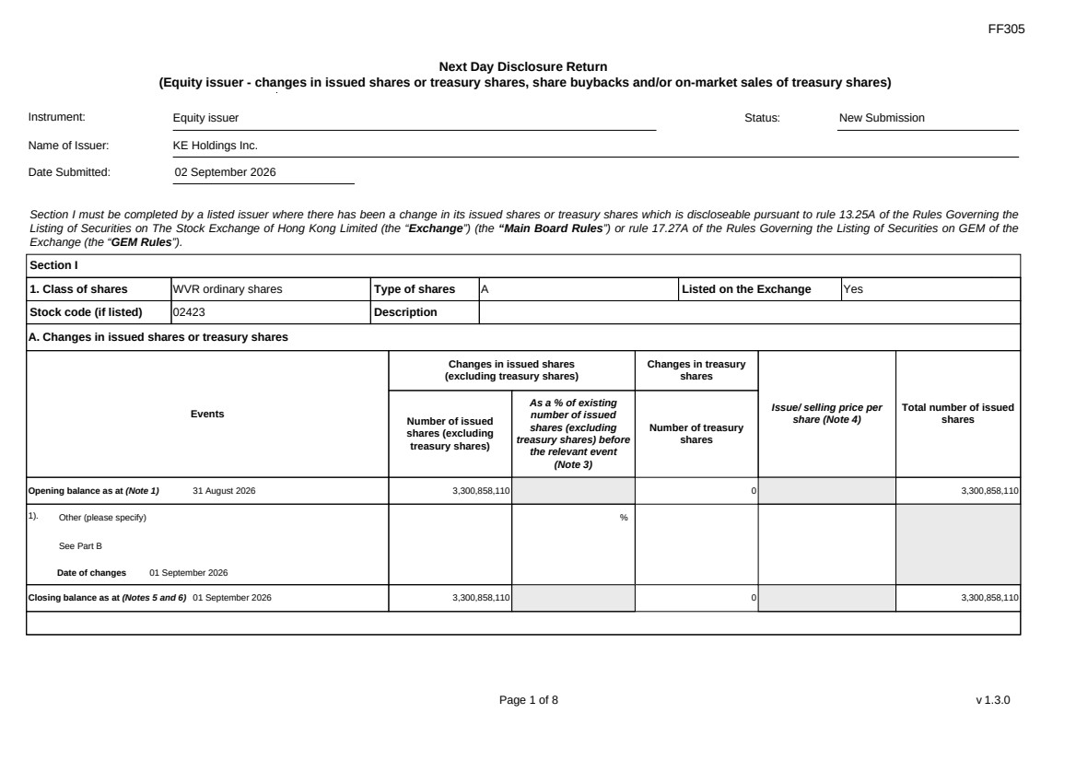 | FF305 Page 1 of 8 v 1.3.0 Next Day Disclosure Return (Equity issuer - changes in issued shares or treasury shares, share buybacks and/or on-market sales of treasury shares) Instrument: Equity issuer Status: New Submission Name of Issuer: KE Holdings Inc. Date Submitted: 02 September 2026 Section I must be completed by a listed issuer where there has been a change in its issued shares or treasury shares which is discloseable pursuant to rule 13.25A of the Rules Governing the Listing of Securities on The Stock Exchange of Hong Kong Limited (the “Exchange”) (the “Main Board Rules”) or rule 17.27A of the Rules Governing the Listing of Securities on GEM of the Exchange (the “GEM Rules”). Section I 1. Class of shares WVR ordinary shares Type of shares A Listed on the Exchange Yes Stock code (if listed) 02423 Description A. Changes in issued shares or treasury shares Events Changes in issued shares (excluding treasury shares) Number of issued shares (excluding treasury shares) As a % of existing number of issued shares (excluding treasury shares) before the relevant event (Note 3) Changes in treasury shares Number of treasury shares Issue/ selling price per share (Note 4) Total number of issued shares Opening balance as at (Note 1) 31 August 2026 3,300,858,110 0 3,300,858,110 1). Other (please specify) See Part B Date of changes 01 September 2026 % Closing balance as at (Notes 5 and 6) 01 September 2026 3,300,858,110 0 3,300,858,110
FF305 Page 2 of 8 v 1.3.0 B. Shares redeemed or repurchased for cancellation but not yet cancelled as at the closing balance date (Notes 5 and 6) 1). Repurchase of shares (or other securities) but not cancelled Date of changes 22 May 2026 464,900 % HKD 43.0128 2). Repurchase of shares (or other securities) but not cancelled Date of changes 26 May 2026 353,400 % HKD 42.4386 3). Repurchase of shares (or other securities) but not cancelled Date of changes 27 May 2026 351,100 % HKD 42.7177 4). Repurchase of shares (or other securities) but not cancelled Date of changes 28 May 2026 353,300 % HKD 42.4549 5). Repurchase of shares (or other securities) but not cancelled Date of changes 29 May 2026 344,000 % HKD 43.4567 6). Repurchase of shares (or other securities) but not cancelled Date of changes 01 June 2026 225,800 % HKD 44.2016 7). Repurchase of shares (or other securities) but not cancelled Date of changes 02 June 2026 221,700 % HKD 45.0078 8). Repurchase of shares (or other securities) but not cancelled in HK Date of changes 03 June 2026 225,300 % HKD 44.1933 9). Repurchase of shares (or other securities) but not cancelled in HK Date of changes 04 June 2026 232,500 % HKD 42.9365 10). Repurchase of shares (or other securities) but not cancelled in HK Date of changes 05 June 2026 234,600 % HKD 42.572 11). Repurchase of shares (or other securities) but not cancelled in HK Date of changes 22 June 2026 331,000 % HKD 38.5996
FF305 Page 3 of 8 v 1.3.0 12). Repurchase of shares (or other securities) but not cancelled in HK Date of changes 23 June 2026 340,200 % HKD 38.1947 13). Repurchase of shares (or other securities) but not cancelled in HK Date of changes 24 June 2026 339,400 % HKD 38.2956 14). Repurchase of shares (or other securities) but not cancelled in HK Date of changes 25 June 2026 344,200 % HKD 37.5842 15). Repurchase of shares (or other securities) but not cancelled in HK Date of changes 26 June 2026 554,200 % HKD 36.0829 16). Repurchase of shares (or other securities) but not cancelled in US Date of changes 03 August 2026 349,611 % USD 5.7206 17). Repurchase of shares (or other securities) but not cancelled in US Date of changes 04 August 2026 350,244 % USD 5.7103 18). Repurchase of shares (or other securities) but not cancelled in US Date of changes 05 August 2026 531,870 % USD 5.6405 19). Repurchase of shares (or other securities) but not cancelled in US Date of changes 06 August 2026 533,037 % USD 5.6281 20). Repurchase of shares (or other securities) but not cancelled in US Date of changes 07 August 2026 349,035 % USD 5.692 21). Repurchase of shares (or other securities) but not cancelled in US Date of changes 10 August 2026 341,265 % USD 5.8605 22). Repurchase of shares (or other securities) but not cancelled in US Date of changes 11 August 2026 529,932 % USD 5.6611 23). Repurchase of shares (or other securities) but not cancelled in US Date of changes 12 August 2026 346,719 % USD 5.7683
 | 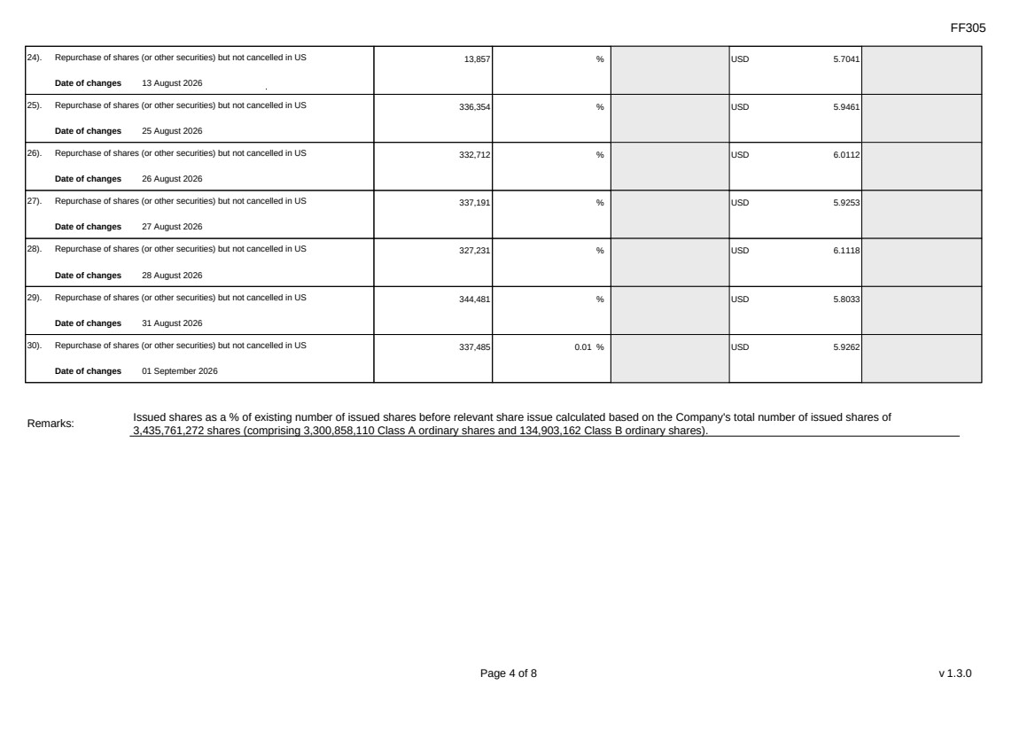 | FF305 Page 4 of 8 v 1.3.0 24). Repurchase of shares (or other securities) but not cancelled in US Date of changes 13 August 2026 13,857 % USD 5.7041 25). Repurchase of shares (or other securities) but not cancelled in US Date of changes 25 August 2026 336,354 % USD 5.9461 26). Repurchase of shares (or other securities) but not cancelled in US Date of changes 26 August 2026 332,712 % USD 6.0112 27). Repurchase of shares (or other securities) but not cancelled in US Date of changes 27 August 2026 337,191 % USD 5.9253 28). Repurchase of shares (or other securities) but not cancelled in US Date of changes 28 August 2026 327,231 % USD 6.1118 29). Repurchase of shares (or other securities) but not cancelled in US Date of changes 31 August 2026 344,481 % USD 5.8033 30). Repurchase of shares (or other securities) but not cancelled in US Date of changes 01 September 2026 337,485 0.01 % USD 5.9262 Remarks: Issued shares as a % of existing number of issued shares before relevant share issue calculated based on the Company's total number of issued shares of 3,435,761,272 shares (comprising 3,300,858,110 Class A ordinary shares and 134,903,162 Class B ordinary shares).
FF305 Page 5 of 8 v 1.3.0 Confirmation Not applicable Notes to Section I: 1. Please insert the closing balance date of the last Next Day Disclosure Return published pursuant to Main Board Rule 13.25A / GEM Rule 17.27A or Monthly Return pursuant to Main Board Rule 13.25B / GEM Rule 17.27B, whichever is the later. 2. Please set out all changes in issued shares or treasury shares requiring disclosure pursuant to Main Board Rule 13.25A / GEM Rule 17.27A together with the relevant dates of changes. Each category will need to be disclosed individually with sufficient information to enable the user to identify the relevant category in the listed issuer's Monthly Return. For example, multiple issues of shares as a result of multiple exercises of share options under the same share option scheme or of multiple conversions under the same convertible note must be aggregated and disclosed as one category. However, if the issues resulted from exercises of share options under 2 share option schemes or conversions of 2 convertible notes, these must be disclosed as 2 separate categories. 3. The percentage change in the number of issued shares (excluding treasury shares) of the listed issuer is to be calculated by reference to the opening balance of the number of issued shares (excluding treasury shares) being disclosed in this Next Day Disclosure Return. 4. In the case of a share repurchase or redemption, the “issue/ selling price per share” shall be construed as “repurchase price per share” or “redemption price per share”. Where shares have been issued/ sold/ repurchased/ redeemed at more than one price per share, a volume-weighted average price per share should be given. 5. The closing balance date is the date of the last relevant event being disclosed. 6. For repurchase or redemption of shares, disclosure is required when the relevant event has occurred (subject to the provisions of Main Board Rules 10.06(4)(a), 13.25A and 13.31 / GEM Rules 13.13(1), 17.27A and 17.35), even if the repurchased or redeemed shares have not yet been cancelled. If repurchased or redeemed shares are to be cancelled upon settlement of such repurchase or redemption after the closing balance date, they shall remain part of the issued shares as at the closing balance date in Part A. Details of these repurchased or redeemed shares shall be disclosed in Part B. 7. Items (i) to (viii) are suggested forms of confirmation. The listed issuer may amend the item(s) that is/are not applicable to meet individual cases. 8. “Identical” means in this context: - the securities are of the same nominal value with the same amount called up or paid up; - they are entitled to dividend/interest at the same rate and for the same period, so that at the next ensuing distribution, the dividend/interest payable per unit will amount to exactly the same sum (gross and net); and - they carry the same rights as to unrestricted transfer, attendance and voting at meetings and rank pari passu in all other respects.
 | 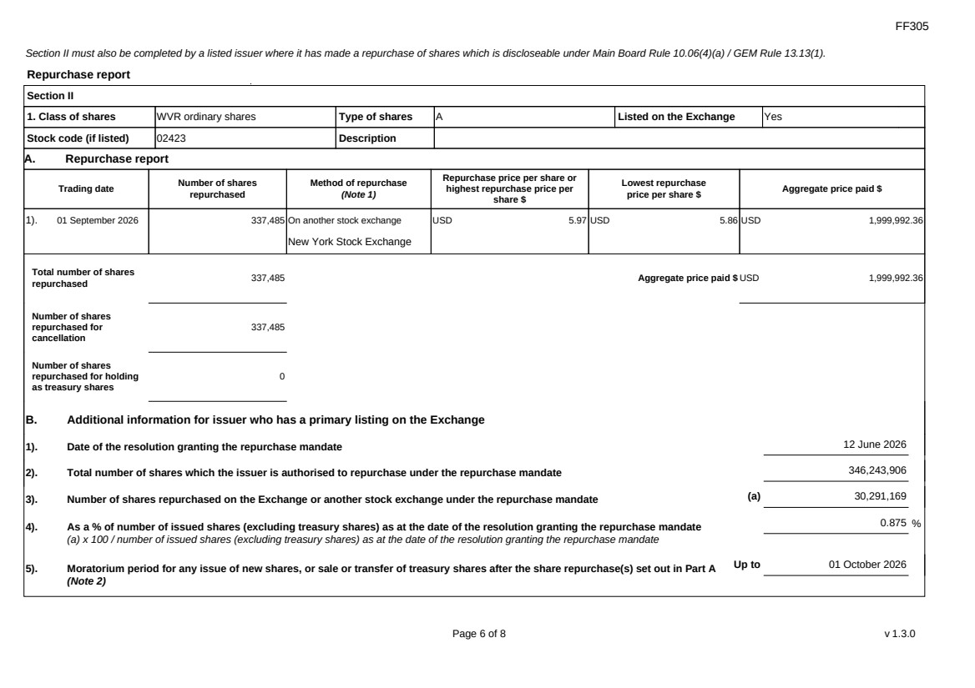 | FF305 Page 6 of 8 v 1.3.0 Section II must also be completed by a listed issuer where it has made a repurchase of shares which is discloseable under Main Board Rule 10.06(4)(a) / GEM Rule 13.13(1). Repurchase report Section II 1. Class of shares WVR ordinary shares Type of shares A Listed on the Exchange Yes Stock code (if listed) 02423 Description A. Repurchase report Trading date Number of shares repurchased Method of repurchase (Note 1) Repurchase price per share or highest repurchase price per share $ Lowest repurchase price per share $ Aggregate price paid $ 1). 01 September 2026 337,485 On another stock exchange New York Stock Exchange USD 5.97 USD 5.86 USD 1,999,992.36 Total number of shares repurchased 337,485 Aggregate price paid $ USD 1,999,992.36 Number of shares repurchased for cancellation 337,485 Number of shares repurchased for holding as treasury shares 0 B. Additional information for issuer who has a primary listing on the Exchange 1). Date of the resolution granting the repurchase mandate 12 June 2026 2). Total number of shares which the issuer is authorised to repurchase under the repurchase mandate 346,243,906 3). Number of shares repurchased on the Exchange or another stock exchange under the repurchase mandate (a) 30,291,169 4). As a % of number of issued shares (excluding treasury shares) as at the date of the resolution granting the repurchase mandate (a) x 100 / number of issued shares (excluding treasury shares) as at the date of the resolution granting the repurchase mandate 0.875 % 5). Moratorium period for any issue of new shares, or sale or transfer of treasury shares after the share repurchase(s) set out in Part A (Note 2) Up to 01 October 2026
FF305 Page 7 of 8 v 1.3.0 We hereby confirm that the repurchases made on the another stock exchange set out in Part A above were made in accordance with the Main Board Rules and that there have been no material changes to the particulars contained in the Explanatory Statement dated 24 April 2026 which has been filed with the Exchange. We also confirm that any repurchases made on another stock exchange set out in Part A above were made in accordance with the domestic rules applying to repurchases on that other stock exchange. Notes to Section II: 1. Please state whether the repurchase was made on the Exchange, on another stock exchange (stating the name of the exchange), by private arrangement or by general offer. 2. Subject to the carve-out set out in Main Board Rule 10.06(3)(a)/ GEM Rule 13.12, an issuer may not (i) make a new issue of shares, or a sale or transfer of any treasury shares; or (ii) announce a proposed new issue of shares, or a sale or transfer of any treasury shares, for a period of 30 days after any purchase by it of shares, whether on the Exchange or otherwise, without the prior approval of the Exchange.
FF305 Page 8 of 8 v 1.3.0 Section III must also be completed by a listed issuer where it has made a sale of treasury shares on the Exchange or any other stock exchange on which the issuer is listed which is discloseable under Main Board Rule 10.06B / GEM Rule 13.14B. Report of on-market sale of treasury shares Not applicable Submitted by: Siting Li (Name) Title: Joint Company Secretary (Director, Secretary or other Duly Authorised Officer)
Exhibit 99.4
 | 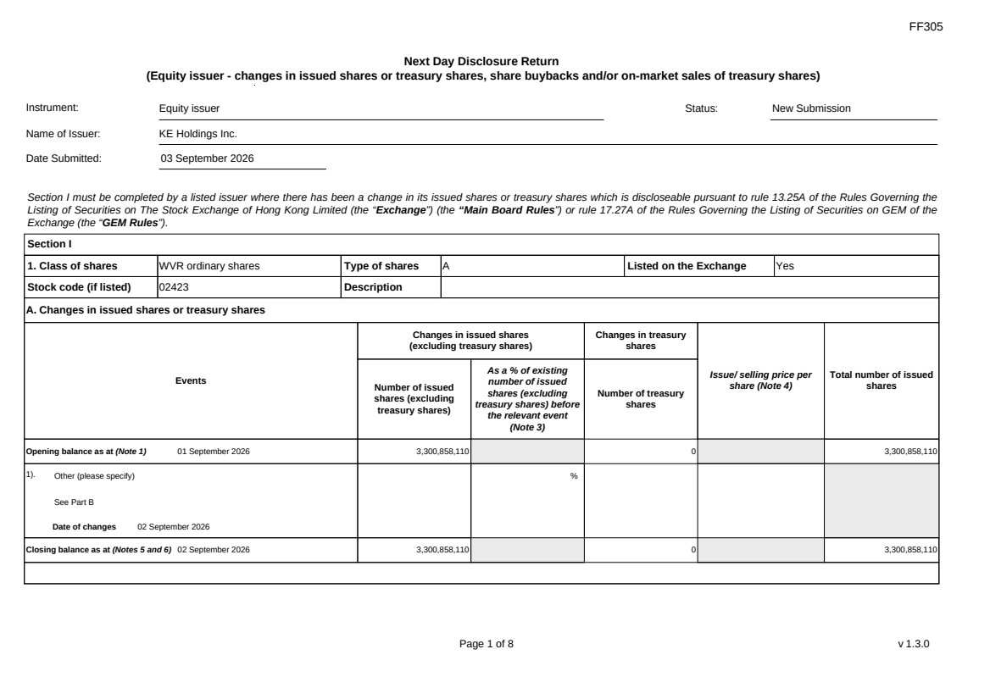 | FF305 Page 1 of 8 v 1.3.0 Next Day Disclosure Return (Equity issuer - changes in issued shares or treasury shares, share buybacks and/or on-market sales of treasury shares) Instrument: Equity issuer Status: New Submission Name of Issuer: KE Holdings Inc. Date Submitted: 03 September 2026 Section I must be completed by a listed issuer where there has been a change in its issued shares or treasury shares which is discloseable pursuant to rule 13.25A of the Rules Governing the Listing of Securities on The Stock Exchange of Hong Kong Limited (the “Exchange”) (the “Main Board Rules”) or rule 17.27A of the Rules Governing the Listing of Securities on GEM of the Exchange (the “GEM Rules”). Section I 1. Class of shares WVR ordinary shares Type of shares A Listed on the Exchange Yes Stock code (if listed) 02423 Description A. Changes in issued shares or treasury shares Events Changes in issued shares (excluding treasury shares) Number of issued shares (excluding treasury shares) As a % of existing number of issued shares (excluding treasury shares) before the relevant event (Note 3) Changes in treasury shares Number of treasury shares Issue/ selling price per share (Note 4) Total number of issued shares Opening balance as at (Note 1) 01 September 2026 3,300,858,110 0 3,300,858,110 1). Other (please specify) See Part B Date of changes 02 September 2026 % Closing balance as at (Notes 5 and 6) 02 September 2026 3,300,858,110 0 3,300,858,110
FF305 Page 2 of 8 v 1.3.0 B. Shares redeemed or repurchased for cancellation but not yet cancelled as at the closing balance date (Notes 5 and 6) 1). Repurchase of shares (or other securities) but not cancelled Date of changes 22 May 2026 464,900 % HKD 43.0128 2). Repurchase of shares (or other securities) but not cancelled Date of changes 26 May 2026 353,400 % HKD 42.4386 3). Repurchase of shares (or other securities) but not cancelled Date of changes 27 May 2026 351,100 % HKD 42.7177 4). Repurchase of shares (or other securities) but not cancelled Date of changes 28 May 2026 353,300 % HKD 42.4549 5). Repurchase of shares (or other securities) but not cancelled Date of changes 29 May 2026 344,000 % HKD 43.4567 6). Repurchase of shares (or other securities) but not cancelled Date of changes 01 June 2026 225,800 % HKD 44.2016 7). Repurchase of shares (or other securities) but not cancelled Date of changes 02 June 2026 221,700 % HKD 45.0078 8). Repurchase of shares (or other securities) but not cancelled in HK Date of changes 03 June 2026 225,300 % HKD 44.1933 9). Repurchase of shares (or other securities) but not cancelled in HK Date of changes 04 June 2026 232,500 % HKD 42.9365 10). Repurchase of shares (or other securities) but not cancelled in HK Date of changes 05 June 2026 234,600 % HKD 42.572 11). Repurchase of shares (or other securities) but not cancelled in HK Date of changes 22 June 2026 331,000 % HKD 38.5996
FF305 Page 3 of 8 v 1.3.0 12). Repurchase of shares (or other securities) but not cancelled in HK Date of changes 23 June 2026 340,200 % HKD 38.1947 13). Repurchase of shares (or other securities) but not cancelled in HK Date of changes 24 June 2026 339,400 % HKD 38.2956 14). Repurchase of shares (or other securities) but not cancelled in HK Date of changes 25 June 2026 344,200 % HKD 37.5842 15). Repurchase of shares (or other securities) but not cancelled in HK Date of changes 26 June 2026 554,200 % HKD 36.0829 16). Repurchase of shares (or other securities) but not cancelled in US Date of changes 03 August 2026 349,611 % USD 5.7206 17). Repurchase of shares (or other securities) but not cancelled in US Date of changes 04 August 2026 350,244 % USD 5.7103 18). Repurchase of shares (or other securities) but not cancelled in US Date of changes 05 August 2026 531,870 % USD 5.6405 19). Repurchase of shares (or other securities) but not cancelled in US Date of changes 06 August 2026 533,037 % USD 5.6281 20). Repurchase of shares (or other securities) but not cancelled in US Date of changes 07 August 2026 349,035 % USD 5.692 21). Repurchase of shares (or other securities) but not cancelled in US Date of changes 10 August 2026 341,265 % USD 5.8605 22). Repurchase of shares (or other securities) but not cancelled in US Date of changes 11 August 2026 529,932 % USD 5.6611 23). Repurchase of shares (or other securities) but not cancelled in US Date of changes 12 August 2026 346,719 % USD 5.7683
 | 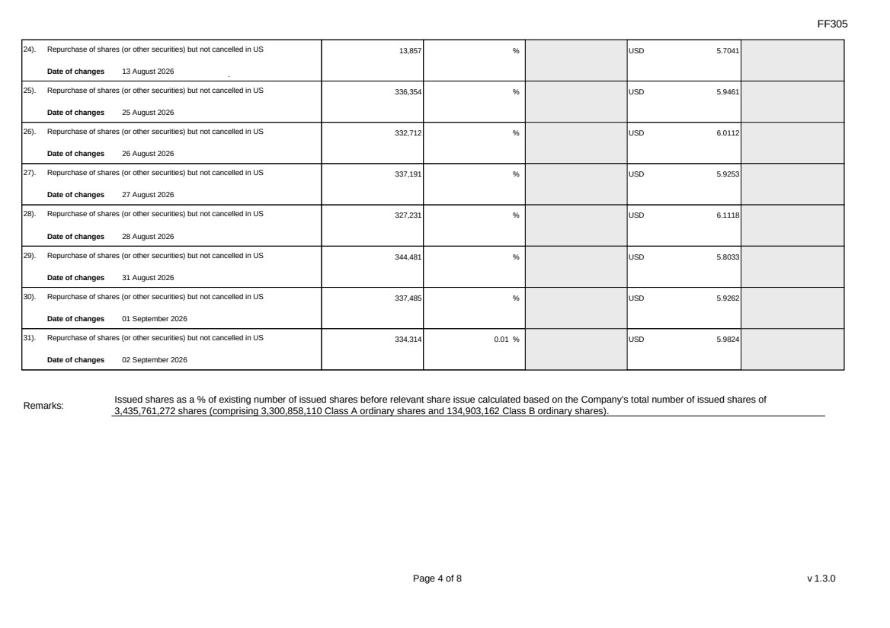 | FF305 Page 4 of 8 v 1.3.0 24). Repurchase of shares (or other securities) but not cancelled in US Date of changes 13 August 2026 13,857 % USD 5.7041 25). Repurchase of shares (or other securities) but not cancelled in US Date of changes 25 August 2026 336,354 % USD 5.9461 26). Repurchase of shares (or other securities) but not cancelled in US Date of changes 26 August 2026 332,712 % USD 6.0112 27). Repurchase of shares (or other securities) but not cancelled in US Date of changes 27 August 2026 337,191 % USD 5.9253 28). Repurchase of shares (or other securities) but not cancelled in US Date of changes 28 August 2026 327,231 % USD 6.1118 29). Repurchase of shares (or other securities) but not cancelled in US Date of changes 31 August 2026 344,481 % USD 5.8033 30). Repurchase of shares (or other securities) but not cancelled in US Date of changes 01 September 2026 337,485 % USD 5.9262 31). Repurchase of shares (or other securities) but not cancelled in US Date of changes 02 September 2026 334,314 0.01 % USD 5.9824 Remarks: Issued shares as a % of existing number of issued shares before relevant share issue calculated based on the Company's total number of issued shares of 3,435,761,272 shares (comprising 3,300,858,110 Class A ordinary shares and 134,903,162 Class B ordinary shares).
FF305 Page 5 of 8 v 1.3.0 Confirmation Not applicable Notes to Section I: 1. Please insert the closing balance date of the last Next Day Disclosure Return published pursuant to Main Board Rule 13.25A / GEM Rule 17.27A or Monthly Return pursuant to Main Board Rule 13.25B / GEM Rule 17.27B, whichever is the later. 2. Please set out all changes in issued shares or treasury shares requiring disclosure pursuant to Main Board Rule 13.25A / GEM Rule 17.27A together with the relevant dates of changes. Each category will need to be disclosed individually with sufficient information to enable the user to identify the relevant category in the listed issuer's Monthly Return. For example, multiple issues of shares as a result of multiple exercises of share options under the same share option scheme or of multiple conversions under the same convertible note must be aggregated and disclosed as one category. However, if the issues resulted from exercises of share options under 2 share option schemes or conversions of 2 convertible notes, these must be disclosed as 2 separate categories. 3. The percentage change in the number of issued shares (excluding treasury shares) of the listed issuer is to be calculated by reference to the opening balance of the number of issued shares (excluding treasury shares) being disclosed in this Next Day Disclosure Return. 4. In the case of a share repurchase or redemption, the “issue/ selling price per share” shall be construed as “repurchase price per share” or “redemption price per share”. Where shares have been issued/ sold/ repurchased/ redeemed at more than one price per share, a volume-weighted average price per share should be given. 5. The closing balance date is the date of the last relevant event being disclosed. 6. For repurchase or redemption of shares, disclosure is required when the relevant event has occurred (subject to the provisions of Main Board Rules 10.06(4)(a), 13.25A and 13.31 / GEM Rules 13.13(1), 17.27A and 17.35), even if the repurchased or redeemed shares have not yet been cancelled. If repurchased or redeemed shares are to be cancelled upon settlement of such repurchase or redemption after the closing balance date, they shall remain part of the issued shares as at the closing balance date in Part A. Details of these repurchased or redeemed shares shall be disclosed in Part B. 7. Items (i) to (viii) are suggested forms of confirmation. The listed issuer may amend the item(s) that is/are not applicable to meet individual cases. 8. “Identical” means in this context: - the securities are of the same nominal value with the same amount called up or paid up; - they are entitled to dividend/interest at the same rate and for the same period, so that at the next ensuing distribution, the dividend/interest payable per unit will amount to exactly the same sum (gross and net); and - they carry the same rights as to unrestricted transfer, attendance and voting at meetings and rank pari passu in all other respects.
 | 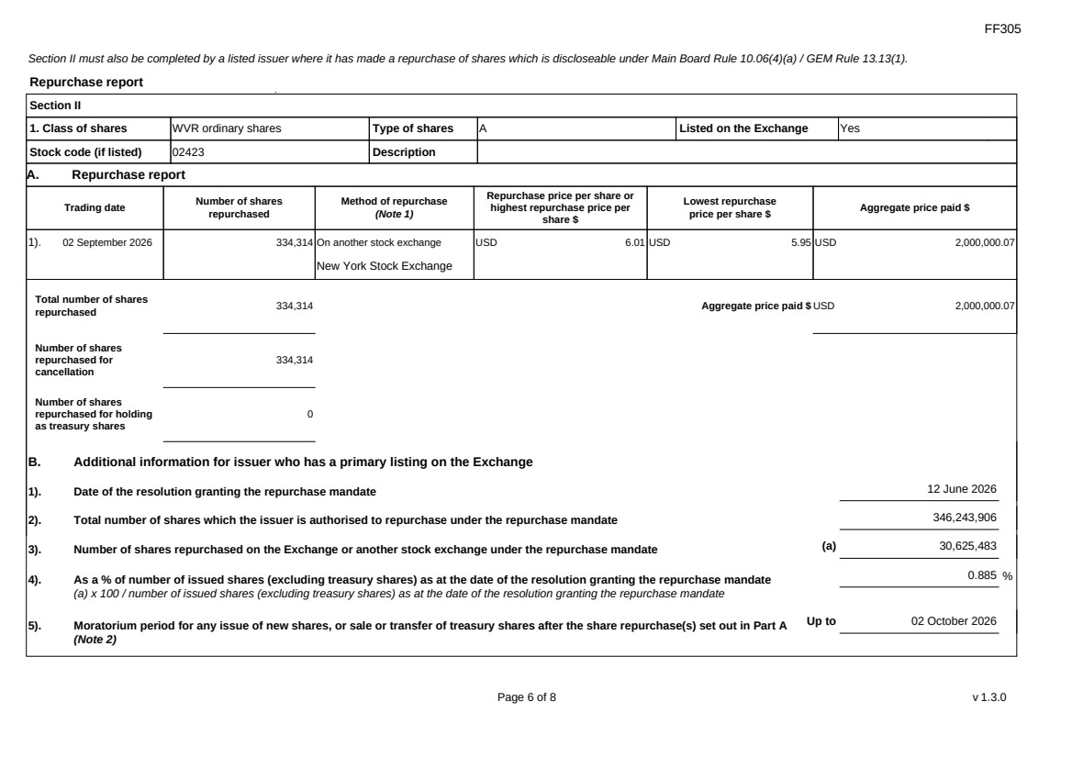 | FF305 Page 6 of 8 v 1.3.0 Section II must also be completed by a listed issuer where it has made a repurchase of shares which is discloseable under Main Board Rule 10.06(4)(a) / GEM Rule 13.13(1). Repurchase report Section II 1. Class of shares WVR ordinary shares Type of shares A Listed on the Exchange Yes Stock code (if listed) 02423 Description A. Repurchase report Trading date Number of shares repurchased Method of repurchase (Note 1) Repurchase price per share or highest repurchase price per share $ Lowest repurchase price per share $ Aggregate price paid $ 1). 02 September 2026 334,314 On another stock exchange New York Stock Exchange USD 6.01 USD 5.95 USD 2,000,000.07 Total number of shares repurchased 334,314 Aggregate price paid $ USD 2,000,000.07 Number of shares repurchased for cancellation 334,314 Number of shares repurchased for holding as treasury shares 0 B. Additional information for issuer who has a primary listing on the Exchange 1). Date of the resolution granting the repurchase mandate 12 June 2026 2). Total number of shares which the issuer is authorised to repurchase under the repurchase mandate 346,243,906 3). Number of shares repurchased on the Exchange or another stock exchange under the repurchase mandate (a) 30,625,483 4). As a % of number of issued shares (excluding treasury shares) as at the date of the resolution granting the repurchase mandate (a) x 100 / number of issued shares (excluding treasury shares) as at the date of the resolution granting the repurchase mandate 0.885 % 5). Moratorium period for any issue of new shares, or sale or transfer of treasury shares after the share repurchase(s) set out in Part A (Note 2) Up to 02 October 2026
FF305 Page 7 of 8 v 1.3.0 We hereby confirm that the repurchases made on the another stock exchange set out in Part A above were made in accordance with the Main Board Rules and that there have been no material changes to the particulars contained in the Explanatory Statement dated 24 April 2026 which has been filed with the Exchange. We also confirm that any repurchases made on another stock exchange set out in Part A above were made in accordance with the domestic rules applying to repurchases on that other stock exchange. Notes to Section II: 1. Please state whether the repurchase was made on the Exchange, on another stock exchange (stating the name of the exchange), by private arrangement or by general offer. 2. Subject to the carve-out set out in Main Board Rule 10.06(3)(a)/ GEM Rule 13.12, an issuer may not (i) make a new issue of shares, or a sale or transfer of any treasury shares; or (ii) announce a proposed new issue of shares, or a sale or transfer of any treasury shares, for a period of 30 days after any purchase by it of shares, whether on the Exchange or otherwise, without the prior approval of the Exchange.
FF305 Page 8 of 8 v 1.3.0 Section III must also be completed by a listed issuer where it has made a sale of treasury shares on the Exchange or any other stock exchange on which the issuer is listed which is discloseable under Main Board Rule 10.06B / GEM Rule 13.14B. Report of on-market sale of treasury shares Not applicable Submitted by: Siting Li (Name) Title: Joint Company Secretary (Director, Secretary or other Duly Authorised Officer)
Exhibit 99.5
 | 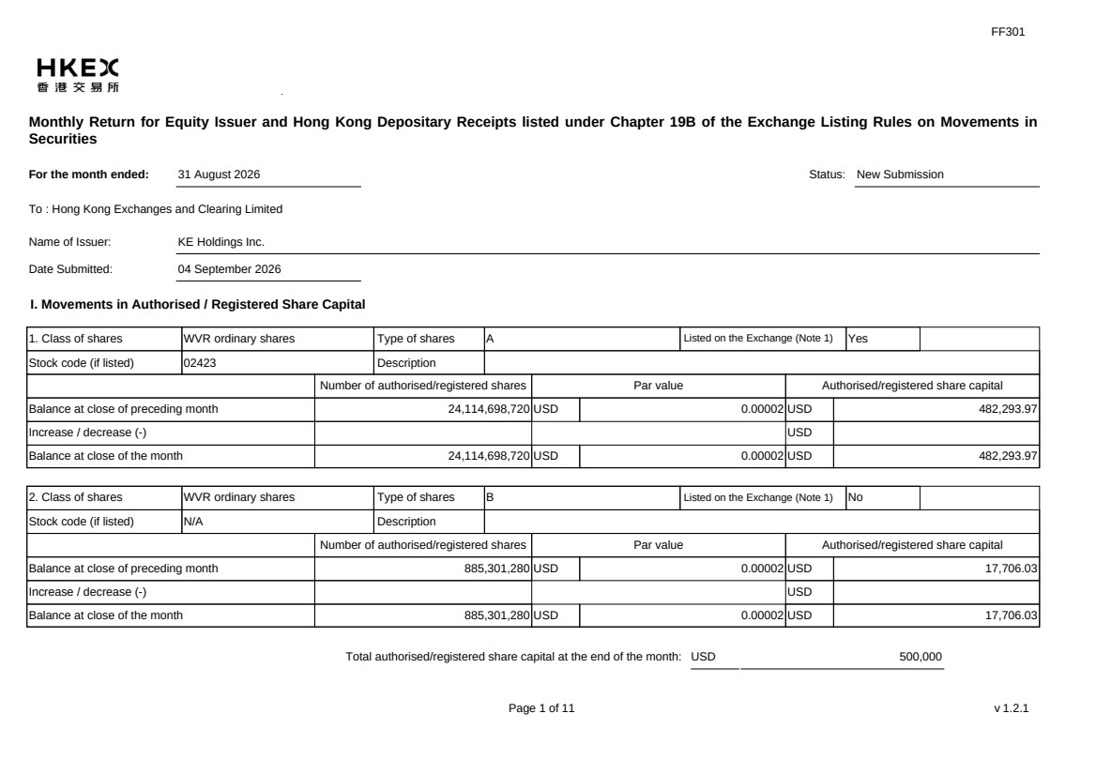 | FF301 Page 1 of 11 v 1.2.1 Monthly Return for Equity Issuer and Hong Kong Depositary Receipts listed under Chapter 19B of the Exchange Listing Rules on Movements in Securities For the month ended: 31 August 2026 Status: New Submission To : Hong Kong Exchanges and Clearing Limited Name of Issuer: KE Holdings Inc. Date Submitted: 04 September 2026 I. Movements in Authorised / Registered Share Capital 1. Class of shares WVR ordinary shares Type of shares A Listed on the Exchange (Note 1) Yes Stock code (if listed) 02423 Description Number of authorised/registered shares Par value Authorised/registered share capital Balance at close of preceding month 24,114,698,720 USD 0.00002 USD 482,293.97 Increase / decrease (-) USD Balance at close of the month 24,114,698,720 USD 0.00002 USD 482,293.97 2. Class of shares WVR ordinary shares Type of shares B Listed on the Exchange (Note 1) No Stock code (if listed) N/A Description Number of authorised/registered shares Par value Authorised/registered share capital Balance at close of preceding month 885,301,280 USD 0.00002 USD 17,706.03 Increase / decrease (-) USD Balance at close of the month 885,301,280 USD 0.00002 USD 17,706.03 Total authorised/registered share capital at the end of the month: USD 500,000
 | 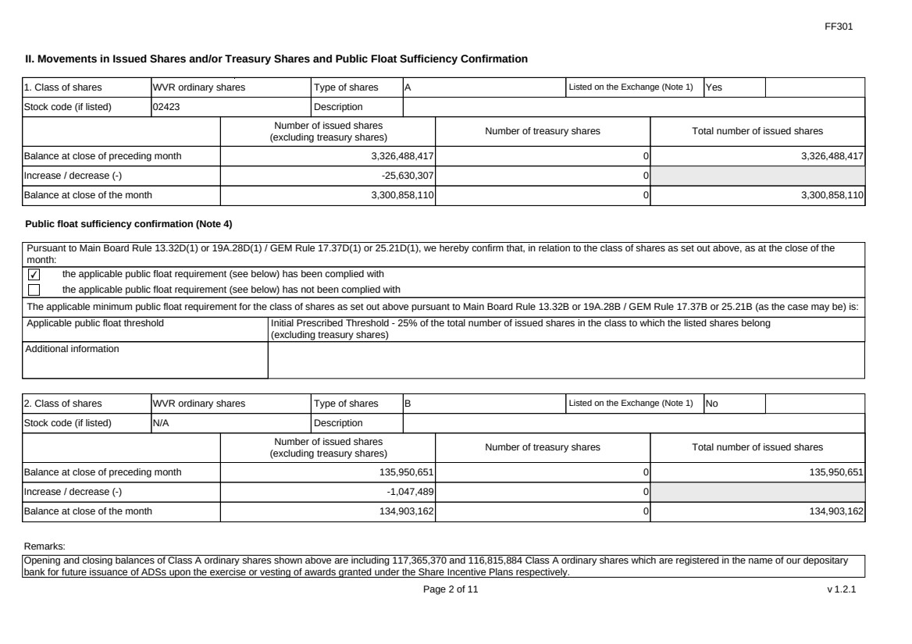 | FF301 Page 2 of 11 v 1.2.1 II. Movements in Issued Shares and/or Treasury Shares and Public Float Sufficiency Confirmation 1. Class of shares WVR ordinary shares Type of shares A Listed on the Exchange (Note 1) Yes Stock code (if listed) 02423 Description Number of issued shares (excluding treasury shares) Number of treasury shares Total number of issued shares Balance at close of preceding month 3,326,488,417 0 3,326,488,417 Increase / decrease (-) -25,630,307 0 Balance at close of the month 3,300,858,110 0 3,300,858,110 Public float sufficiency confirmation (Note 4) Pursuant to Main Board Rule 13.32D(1) or 19A.28D(1) / GEM Rule 17.37D(1) or 25.21D(1), we hereby confirm that, in relation to the class of shares as set out above, as at the close of the month: ✔ the applicable public float requirement (see below) has been complied with the applicable public float requirement (see below) has not been complied with The applicable minimum public float requirement for the class of shares as set out above pursuant to Main Board Rule 13.32B or 19A.28B / GEM Rule 17.37B or 25.21B (as the case may be) is: Applicable public float threshold Initial Prescribed Threshold - 25% of the total number of issued shares in the class to which the listed shares belong (excluding treasury shares) Additional information 2. Class of shares WVR ordinary shares Type of shares B Listed on the Exchange (Note 1) No Stock code (if listed) N/A Description Number of issued shares (excluding treasury shares) Number of treasury shares Total number of issued shares Balance at close of preceding month 135,950,651 0 135,950,651 Increase / decrease (-) -1,047,489 0 Balance at close of the month 134,903,162 0 134,903,162 Remarks: Opening and closing balances of Class A ordinary shares shown above are including 117,365,370 and 116,815,884 Class A ordinary shares which are registered in the name of our depositary bank for future issuance of ADSs upon the exercise or vesting of awards granted under the Share Incentive Plans respectively.
 | 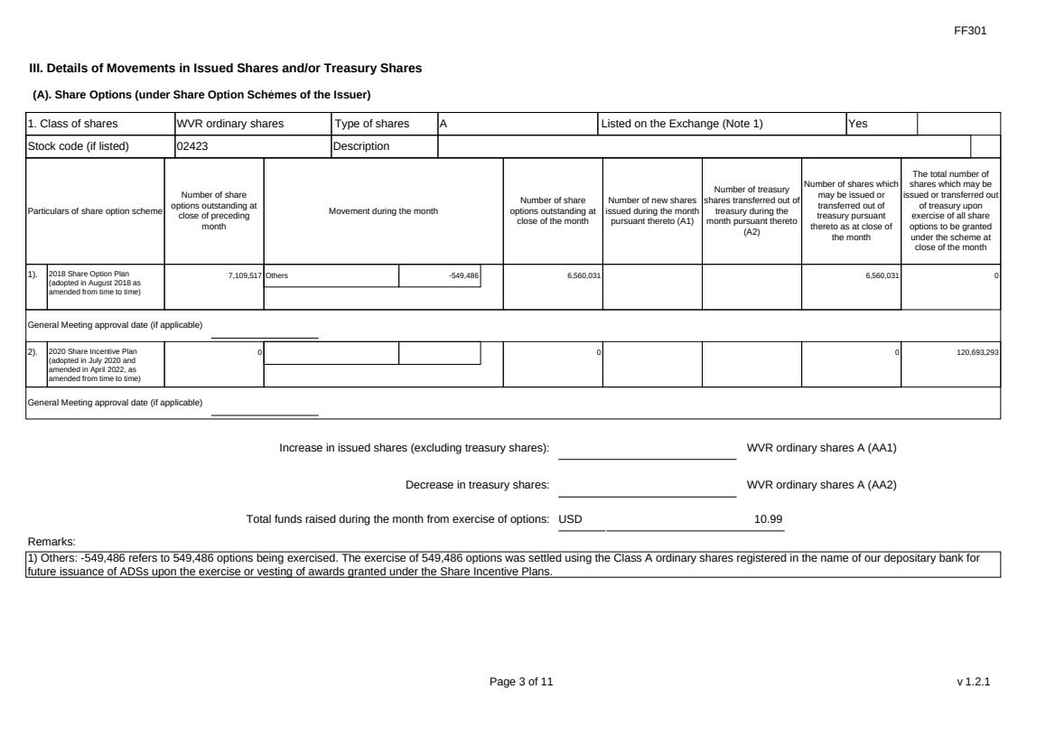 | FF301 Page 3 of 11 v 1.2.1 III. Details of Movements in Issued Shares and/or Treasury Shares (A). Share Options (under Share Option Schemes of the Issuer) 1. Class of shares WVR ordinary shares Type of shares A Listed on the Exchange (Note 1) Yes Stock code (if listed) 02423 Description Particulars of share option scheme Number of share options outstanding at close of preceding month Movement during the month Number of share options outstanding at close of the month Number of new shares issued during the month pursuant thereto (A1) Number of treasury shares transferred out of treasury during the month pursuant thereto (A2) Number of shares which may be issued or transferred out of treasury pursuant thereto as at close of the month The total number of shares which may be issued or transferred out of treasury upon exercise of all share options to be granted under the scheme at close of the month 1). 2018 Share Option Plan (adopted in August 2018 as amended from time to time) 7,109,517 Others -549,486 6,560,031 6,560,031 0 General Meeting approval date (if applicable) 2). 2020 Share Incentive Plan (adopted in July 2020 and amended in April 2022, as amended from time to time) 0 0 0 120,693,293 General Meeting approval date (if applicable) Increase in issued shares (excluding treasury shares): WVR ordinary shares A (AA1) Decrease in treasury shares: WVR ordinary shares A (AA2) Total funds raised during the month from exercise of options: USD 10.99 Remarks: 1) Others: -549,486 refers to 549,486 options being exercised. The exercise of 549,486 options was settled using the Class A ordinary shares registered in the name of our depositary bank for future issuance of ADSs upon the exercise or vesting of awards granted under the Share Incentive Plans.
 |  | FF301 Page 4 of 11 v 1.2.1 (B). Warrants to Issue Shares of the Issuer Not applicable
 | 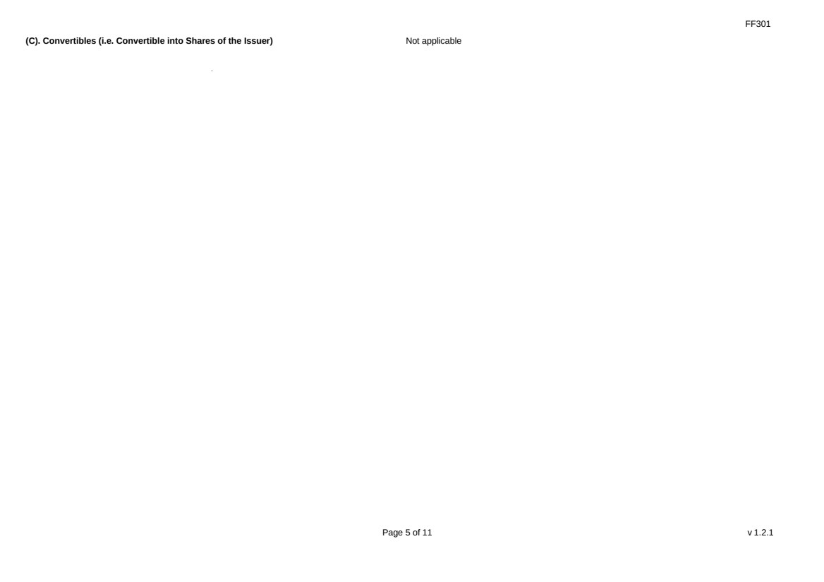 | FF301 Page 5 of 11 v 1.2.1 (C). Convertibles (i.e. Convertible into Shares of the Issuer) Not applicable
 | 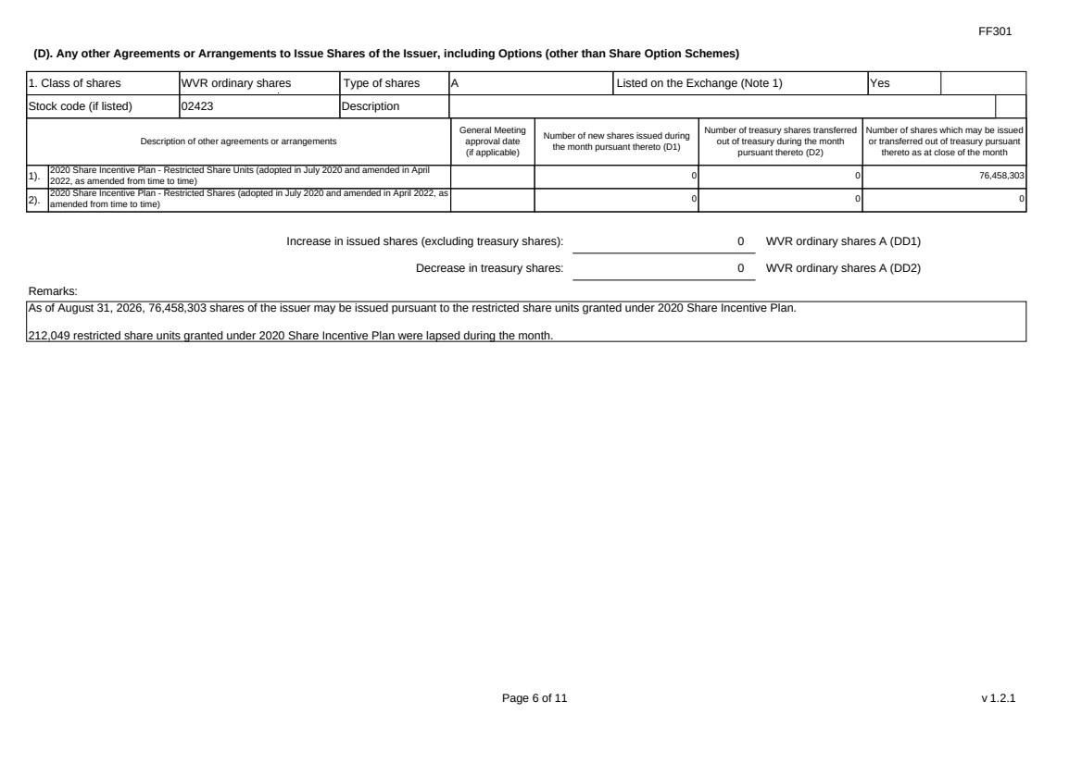 | FF301 Page 6 of 11 v 1.2.1 (D). Any other Agreements or Arrangements to Issue Shares of the Issuer, including Options (other than Share Option Schemes) 1. Class of shares WVR ordinary shares Type of shares A Listed on the Exchange (Note 1) Yes Stock code (if listed) 02423 Description Description of other agreements or arrangements General Meeting approval date (if applicable) Number of new shares issued during the month pursuant thereto (D1) Number of treasury shares transferred out of treasury during the month pursuant thereto (D2) Number of shares which may be issued or transferred out of treasury pursuant thereto as at close of the month 1). 2020 Share Incentive Plan - Restricted Share Units (adopted in July 2020 and amended in April 2022, as amended from time to time) 0 0 76,458,303 2). 2020 Share Incentive Plan - Restricted Shares (adopted in July 2020 and amended in April 2022, as amended from time to time) 0 0 0 Increase in issued shares (excluding treasury shares): 0 WVR ordinary shares A (DD1) Decrease in treasury shares: 0 WVR ordinary shares A (DD2) Remarks: As of August 31, 2026, 76,458,303 shares of the issuer may be issued pursuant to the restricted share units granted under 2020 Share Incentive Plan. 212,049 restricted share units granted under 2020 Share Incentive Plan were lapsed during the month.
 | 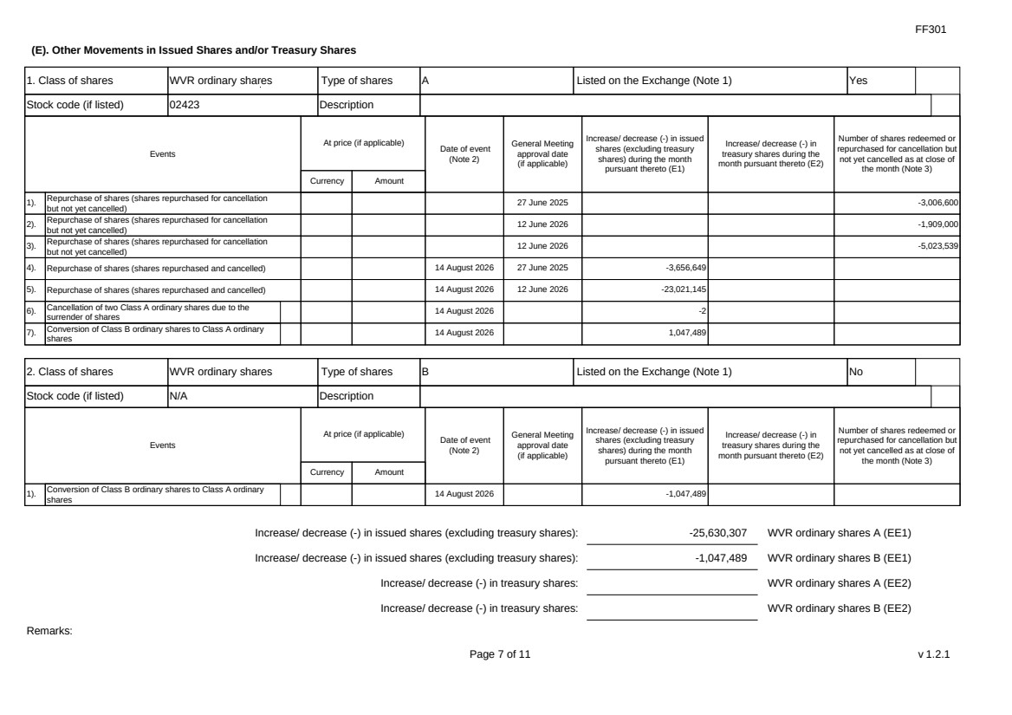 | FF301 Page 7 of 11 v 1.2.1 (E). Other Movements in Issued Shares and/or Treasury Shares 1. Class of shares WVR ordinary shares Type of shares A Listed on the Exchange (Note 1) Yes Stock code (if listed) 02423 Description Events At price (if applicable) Currency Amount Date of event (Note 2) General Meeting approval date (if applicable) Increase/ decrease (-) in issued shares (excluding treasury shares) during the month pursuant thereto (E1) Increase/ decrease (-) in treasury shares during the month pursuant thereto (E2) Number of shares redeemed or repurchased for cancellation but not yet cancelled as at close of the month (Note 3) 1). Repurchase of shares (shares repurchased for cancellation but not yet cancelled) 27 June 2025 -3,006,600 2). Repurchase of shares (shares repurchased for cancellation but not yet cancelled) 12 June 2026 -1,909,000 3). Repurchase of shares (shares repurchased for cancellation but not yet cancelled) 12 June 2026 -5,023,539 4). Repurchase of shares (shares repurchased and cancelled) 14 August 2026 27 June 2025 -3,656,649 5). Repurchase of shares (shares repurchased and cancelled) 14 August 2026 12 June 2026 -23,021,145 6). Cancellation of two Class A ordinary shares due to the surrender of shares 14 August 2026 -2 7). Conversion of Class B ordinary shares to Class A ordinary shares 14 August 2026 1,047,489 2. Class of shares WVR ordinary shares Type of shares B Listed on the Exchange (Note 1) No Stock code (if listed) N/A Description Events At price (if applicable) Currency Amount Date of event (Note 2) General Meeting approval date (if applicable) Increase/ decrease (-) in issued shares (excluding treasury shares) during the month pursuant thereto (E1) Increase/ decrease (-) in treasury shares during the month pursuant thereto (E2) Number of shares redeemed or repurchased for cancellation but not yet cancelled as at close of the month (Note 3) 1). Conversion of Class B ordinary shares to Class A ordinary shares 14 August 2026 -1,047,489 Increase/ decrease (-) in issued shares (excluding treasury shares): -25,630,307 WVR ordinary shares A (EE1) Increase/ decrease (-) in issued shares (excluding treasury shares): -1,047,489 WVR ordinary shares B (EE1) Increase/ decrease (-) in treasury shares: WVR ordinary shares A (EE2) Increase/ decrease (-) in treasury shares: WVR ordinary shares B (EE2) Remarks:
 | 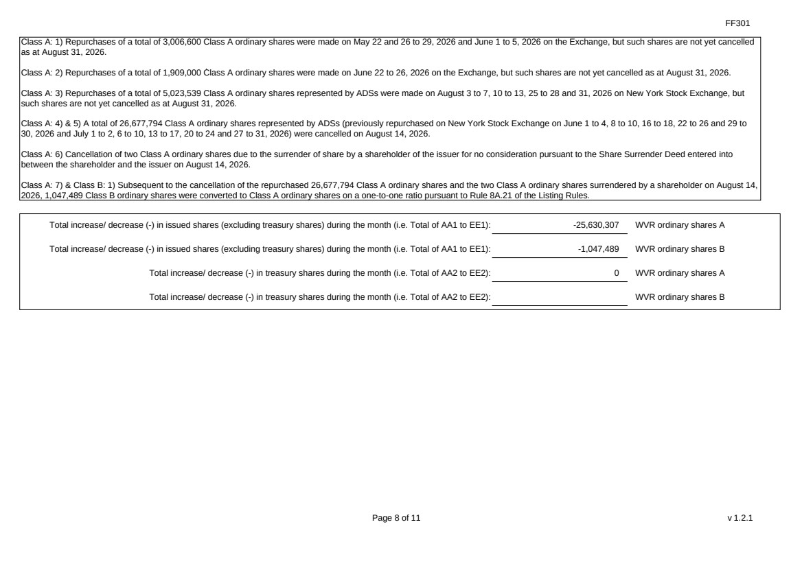 | FF301 Page 8 of 11 v 1.2.1 Class A: 1) Repurchases of a total of 3,006,600 Class A ordinary shares were made on May 22 and 26 to 29, 2026 and June 1 to 5, 2026 on the Exchange, but such shares are not yet cancelled as at August 31, 2026. Class A: 2) Repurchases of a total of 1,909,000 Class A ordinary shares were made on June 22 to 26, 2026 on the Exchange, but such shares are not yet cancelled as at August 31, 2026. Class A: 3) Repurchases of a total of 5,023,539 Class A ordinary shares represented by ADSs were made on August 3 to 7, 10 to 13, 25 to 28 and 31, 2026 on New York Stock Exchange, but such shares are not yet cancelled as at August 31, 2026. Class A: 4) & 5) A total of 26,677,794 Class A ordinary shares represented by ADSs (previously repurchased on New York Stock Exchange on June 1 to 4, 8 to 10, 16 to 18, 22 to 26 and 29 to 30, 2026 and July 1 to 2, 6 to 10, 13 to 17, 20 to 24 and 27 to 31, 2026) were cancelled on August 14, 2026. Class A: 6) Cancellation of two Class A ordinary shares due to the surrender of share by a shareholder of the issuer for no consideration pursuant to the Share Surrender Deed entered into between the shareholder and the issuer on August 14, 2026. Class A: 7) & Class B: 1) Subsequent to the cancellation of the repurchased 26,677,794 Class A ordinary shares and the two Class A ordinary shares surrendered by a shareholder on August 14, 2026, 1,047,489 Class B ordinary shares were converted to Class A ordinary shares on a one-to-one ratio pursuant to Rule 8A.21 of the Listing Rules. Total increase/ decrease (-) in issued shares (excluding treasury shares) during the month (i.e. Total of AA1 to EE1): -25,630,307 WVR ordinary shares A Total increase/ decrease (-) in issued shares (excluding treasury shares) during the month (i.e. Total of AA1 to EE1): -1,047,489 WVR ordinary shares B Total increase/ decrease (-) in treasury shares during the month (i.e. Total of AA2 to EE2): 0 WVR ordinary shares A Total increase/ decrease (-) in treasury shares during the month (i.e. Total of AA2 to EE2): WVR ordinary shares B
 | 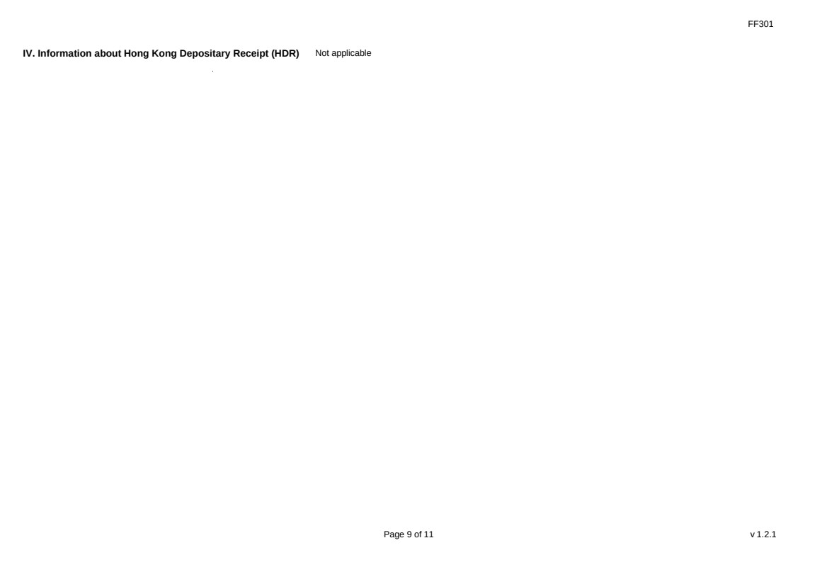 | FF301 Page 9 of 11 v 1.2.1 IV. Information about Hong Kong Depositary Receipt (HDR) Not applicable
 | 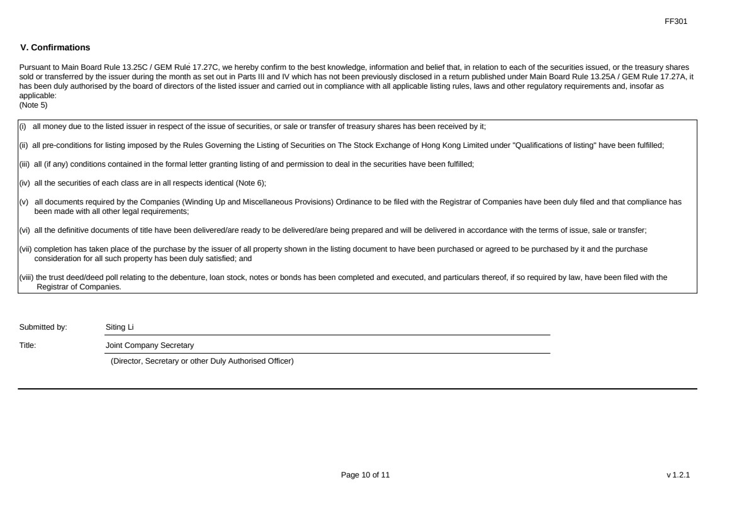 | FF301 Page 10 of 11 v 1.2.1 V. Confirmations Pursuant to Main Board Rule 13.25C / GEM Rule 17.27C, we hereby confirm to the best knowledge, information and belief that, in relation to each of the securities issued, or the treasury shares sold or transferred by the issuer during the month as set out in Parts III and IV which has not been previously disclosed in a return published under Main Board Rule 13.25A / GEM Rule 17.27A, it has been duly authorised by the board of directors of the listed issuer and carried out in compliance with all applicable listing rules, laws and other regulatory requirements and, insofar as applicable: (Note 5) (i) all money due to the listed issuer in respect of the issue of securities, or sale or transfer of treasury shares has been received by it; (ii) all pre-conditions for listing imposed by the Rules Governing the Listing of Securities on The Stock Exchange of Hong Kong Limited under "Qualifications of listing" have been fulfilled; (iii) all (if any) conditions contained in the formal letter granting listing of and permission to deal in the securities have been fulfilled; (iv) all the securities of each class are in all respects identical (Note 6); (v) all documents required by the Companies (Winding Up and Miscellaneous Provisions) Ordinance to be filed with the Registrar of Companies have been duly filed and that compliance has been made with all other legal requirements; (vi) all the definitive documents of title have been delivered/are ready to be delivered/are being prepared and will be delivered in accordance with the terms of issue, sale or transfer; (vii) completion has taken place of the purchase by the issuer of all property shown in the listing document to have been purchased or agreed to be purchased by it and the purchase consideration for all such property has been duly satisfied; and (viii) the trust deed/deed poll relating to the debenture, loan stock, notes or bonds has been completed and executed, and particulars thereof, if so required by law, have been filed with the Registrar of Companies. Submitted by: Siting Li Title: Joint Company Secretary (Director, Secretary or other Duly Authorised Officer)
 | 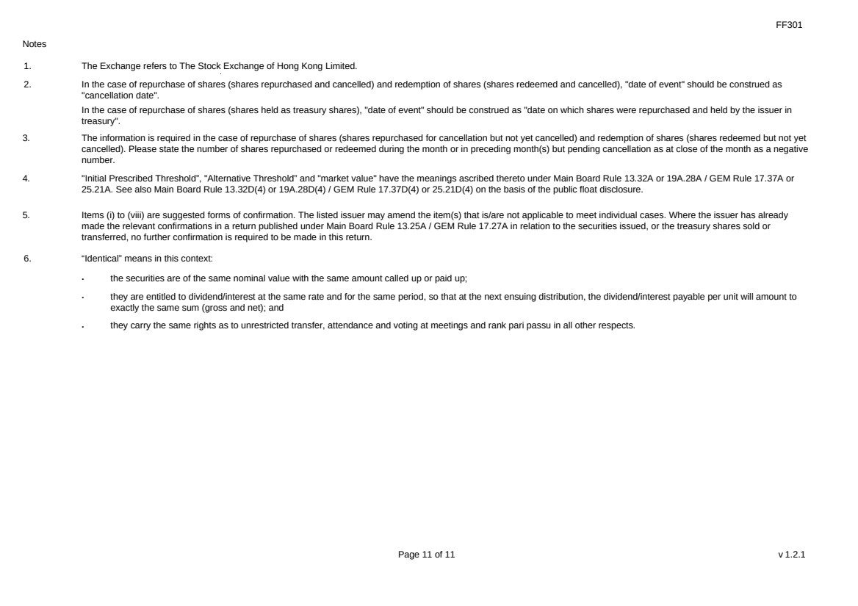 | FF301 Page 11 of 11 v 1.2.1 Notes 1. The Exchange refers to The Stock Exchange of Hong Kong Limited. 2. In the case of repurchase of shares (shares repurchased and cancelled) and redemption of shares (shares redeemed and cancelled), "date of event" should be construed as "cancellation date". In the case of repurchase of shares (shares held as treasury shares), "date of event" should be construed as "date on which shares were repurchased and held by the issuer in treasury". 3. The information is required in the case of repurchase of shares (shares repurchased for cancellation but not yet cancelled) and redemption of shares (shares redeemed but not yet cancelled). Please state the number of shares repurchased or redeemed during the month or in preceding month(s) but pending cancellation as at close of the month as a negative number. 4. "Initial Prescribed Threshold”, "Alternative Threshold” and "market value" have the meanings ascribed thereto under Main Board Rule 13.32A or 19A.28A / GEM Rule 17.37A or 25.21A. See also Main Board Rule 13.32D(4) or 19A.28D(4) / GEM Rule 17.37D(4) or 25.21D(4) on the basis of the public float disclosure. 5. Items (i) to (viii) are suggested forms of confirmation. The listed issuer may amend the item(s) that is/are not applicable to meet individual cases. Where the issuer has already made the relevant confirmations in a return published under Main Board Rule 13.25A / GEM Rule 17.27A in relation to the securities issued, or the treasury shares sold or transferred, no further confirmation is required to be made in this return. 6. “Identical” means in this context: ． the securities are of the same nominal value with the same amount called up or paid up; ． they are entitled to dividend/interest at the same rate and for the same period, so that at the next ensuing distribution, the dividend/interest payable per unit will amount to exactly the same sum (gross and net); and ． they carry the same rights as to unrestricted transfer, attendance and voting at meetings and rank pari passu in all other respects.
Exhibit 99.6
 | 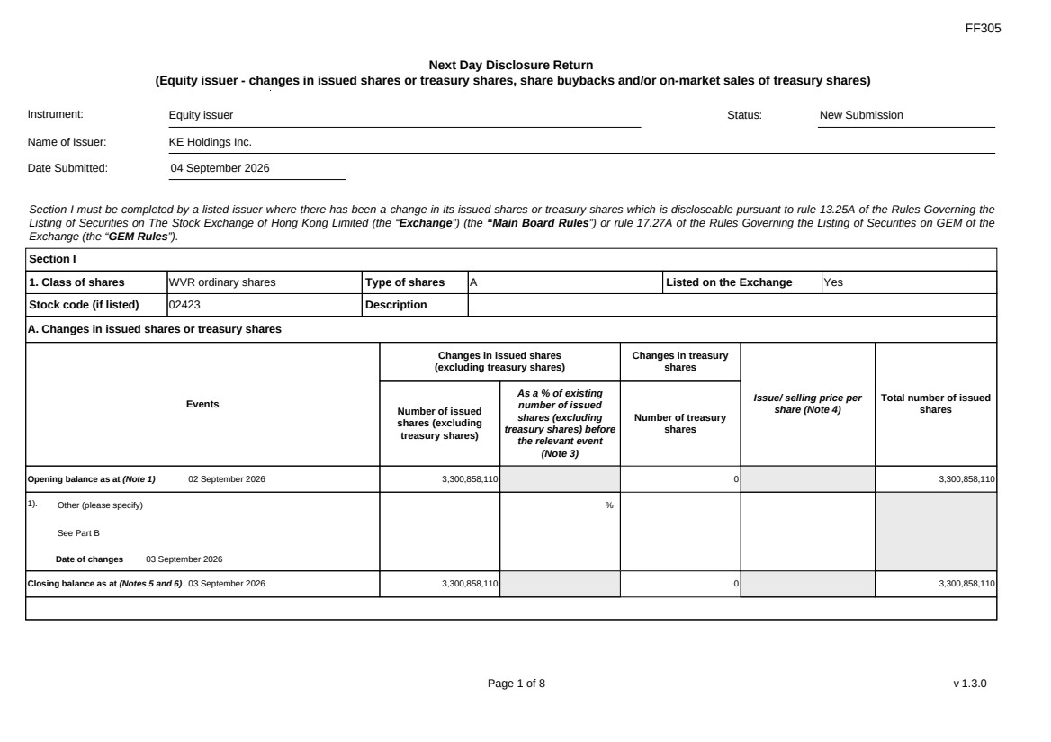 | FF305 Page 1 of 8 v 1.3.0 Next Day Disclosure Return (Equity issuer - changes in issued shares or treasury shares, share buybacks and/or on-market sales of treasury shares) Instrument: Equity issuer Status: New Submission Name of Issuer: KE Holdings Inc. Date Submitted: 04 September 2026 Section I must be completed by a listed issuer where there has been a change in its issued shares or treasury shares which is discloseable pursuant to rule 13.25A of the Rules Governing the Listing of Securities on The Stock Exchange of Hong Kong Limited (the “Exchange”) (the “Main Board Rules”) or rule 17.27A of the Rules Governing the Listing of Securities on GEM of the Exchange (the “GEM Rules”). Section I 1. Class of shares WVR ordinary shares Type of shares A Listed on the Exchange Yes Stock code (if listed) 02423 Description A. Changes in issued shares or treasury shares Events Changes in issued shares (excluding treasury shares) Number of issued shares (excluding treasury shares) As a % of existing number of issued shares (excluding treasury shares) before the relevant event (Note 3) Changes in treasury shares Number of treasury shares Issue/ selling price per share (Note 4) Total number of issued shares Opening balance as at (Note 1) 02 September 2026 3,300,858,110 0 3,300,858,110 1). Other (please specify) See Part B Date of changes 03 September 2026 % Closing balance as at (Notes 5 and 6) 03 September 2026 3,300,858,110 0 3,300,858,110
FF305 Page 2 of 8 v 1.3.0 B. Shares redeemed or repurchased for cancellation but not yet cancelled as at the closing balance date (Notes 5 and 6) 1). Repurchase of shares (or other securities) but not cancelled Date of changes 22 May 2026 464,900 % HKD 43.0128 2). Repurchase of shares (or other securities) but not cancelled Date of changes 26 May 2026 353,400 % HKD 42.4386 3). Repurchase of shares (or other securities) but not cancelled Date of changes 27 May 2026 351,100 % HKD 42.7177 4). Repurchase of shares (or other securities) but not cancelled Date of changes 28 May 2026 353,300 % HKD 42.4549 5). Repurchase of shares (or other securities) but not cancelled Date of changes 29 May 2026 344,000 % HKD 43.4567 6). Repurchase of shares (or other securities) but not cancelled Date of changes 01 June 2026 225,800 % HKD 44.2016 7). Repurchase of shares (or other securities) but not cancelled Date of changes 02 June 2026 221,700 % HKD 45.0078 8). Repurchase of shares (or other securities) but not cancelled in HK Date of changes 03 June 2026 225,300 % HKD 44.1933 9). Repurchase of shares (or other securities) but not cancelled in HK Date of changes 04 June 2026 232,500 % HKD 42.9365 10). Repurchase of shares (or other securities) but not cancelled in HK Date of changes 05 June 2026 234,600 % HKD 42.572 11). Repurchase of shares (or other securities) but not cancelled in HK Date of changes 22 June 2026 331,000 % HKD 38.5996
FF305 Page 3 of 8 v 1.3.0 12). Repurchase of shares (or other securities) but not cancelled in HK Date of changes 23 June 2026 340,200 % HKD 38.1947 13). Repurchase of shares (or other securities) but not cancelled in HK Date of changes 24 June 2026 339,400 % HKD 38.2956 14). Repurchase of shares (or other securities) but not cancelled in HK Date of changes 25 June 2026 344,200 % HKD 37.5842 15). Repurchase of shares (or other securities) but not cancelled in HK Date of changes 26 June 2026 554,200 % HKD 36.0829 16). Repurchase of shares (or other securities) but not cancelled in US Date of changes 03 August 2026 349,611 % USD 5.7206 17). Repurchase of shares (or other securities) but not cancelled in US Date of changes 04 August 2026 350,244 % USD 5.7103 18). Repurchase of shares (or other securities) but not cancelled in US Date of changes 05 August 2026 531,870 % USD 5.6405 19). Repurchase of shares (or other securities) but not cancelled in US Date of changes 06 August 2026 533,037 % USD 5.6281 20). Repurchase of shares (or other securities) but not cancelled in US Date of changes 07 August 2026 349,035 % USD 5.692 21). Repurchase of shares (or other securities) but not cancelled in US Date of changes 10 August 2026 341,265 % USD 5.8605 22). Repurchase of shares (or other securities) but not cancelled in US Date of changes 11 August 2026 529,932 % USD 5.6611 23). Repurchase of shares (or other securities) but not cancelled in US Date of changes 12 August 2026 346,719 % USD 5.7683
 | 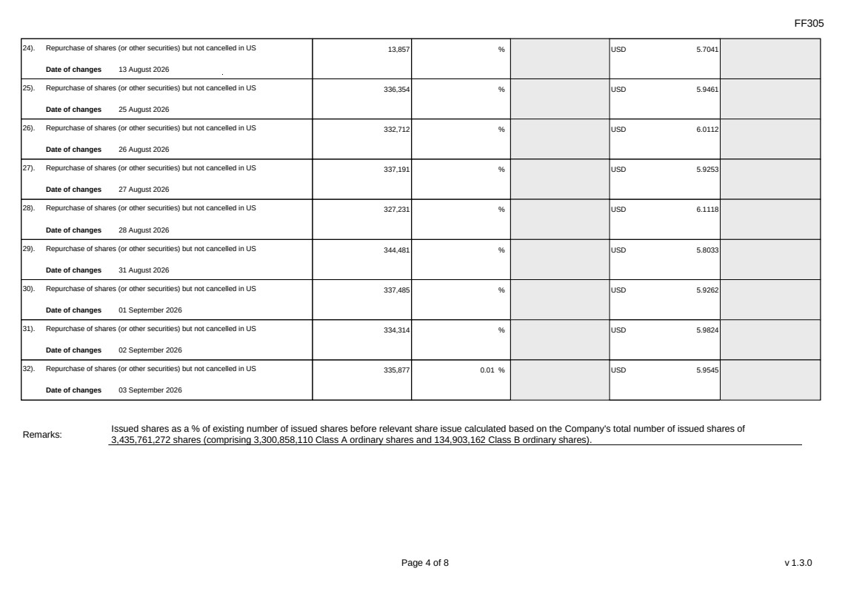 | FF305 Page 4 of 8 v 1.3.0 24). Repurchase of shares (or other securities) but not cancelled in US Date of changes 13 August 2026 13,857 % USD 5.7041 25). Repurchase of shares (or other securities) but not cancelled in US Date of changes 25 August 2026 336,354 % USD 5.9461 26). Repurchase of shares (or other securities) but not cancelled in US Date of changes 26 August 2026 332,712 % USD 6.0112 27). Repurchase of shares (or other securities) but not cancelled in US Date of changes 27 August 2026 337,191 % USD 5.9253 28). Repurchase of shares (or other securities) but not cancelled in US Date of changes 28 August 2026 327,231 % USD 6.1118 29). Repurchase of shares (or other securities) but not cancelled in US Date of changes 31 August 2026 344,481 % USD 5.8033 30). Repurchase of shares (or other securities) but not cancelled in US Date of changes 01 September 2026 337,485 % USD 5.9262 31). Repurchase of shares (or other securities) but not cancelled in US Date of changes 02 September 2026 334,314 % USD 5.9824 32). Repurchase of shares (or other securities) but not cancelled in US Date of changes 03 September 2026 335,877 0.01 % USD 5.9545 Remarks: Issued shares as a % of existing number of issued shares before relevant share issue calculated based on the Company's total number of issued shares of 3,435,761,272 shares (comprising 3,300,858,110 Class A ordinary shares and 134,903,162 Class B ordinary shares).
FF305 Page 5 of 8 v 1.3.0 Confirmation Not applicable Notes to Section I: 1. Please insert the closing balance date of the last Next Day Disclosure Return published pursuant to Main Board Rule 13.25A / GEM Rule 17.27A or Monthly Return pursuant to Main Board Rule 13.25B / GEM Rule 17.27B, whichever is the later. 2. Please set out all changes in issued shares or treasury shares requiring disclosure pursuant to Main Board Rule 13.25A / GEM Rule 17.27A together with the relevant dates of changes. Each category will need to be disclosed individually with sufficient information to enable the user to identify the relevant category in the listed issuer's Monthly Return. For example, multiple issues of shares as a result of multiple exercises of share options under the same share option scheme or of multiple conversions under the same convertible note must be aggregated and disclosed as one category. However, if the issues resulted from exercises of share options under 2 share option schemes or conversions of 2 convertible notes, these must be disclosed as 2 separate categories. 3. The percentage change in the number of issued shares (excluding treasury shares) of the listed issuer is to be calculated by reference to the opening balance of the number of issued shares (excluding treasury shares) being disclosed in this Next Day Disclosure Return. 4. In the case of a share repurchase or redemption, the “issue/ selling price per share” shall be construed as “repurchase price per share” or “redemption price per share”. Where shares have been issued/ sold/ repurchased/ redeemed at more than one price per share, a volume-weighted average price per share should be given. 5. The closing balance date is the date of the last relevant event being disclosed. 6. For repurchase or redemption of shares, disclosure is required when the relevant event has occurred (subject to the provisions of Main Board Rules 10.06(4)(a), 13.25A and 13.31 / GEM Rules 13.13(1), 17.27A and 17.35), even if the repurchased or redeemed shares have not yet been cancelled. If repurchased or redeemed shares are to be cancelled upon settlement of such repurchase or redemption after the closing balance date, they shall remain part of the issued shares as at the closing balance date in Part A. Details of these repurchased or redeemed shares shall be disclosed in Part B. 7. Items (i) to (viii) are suggested forms of confirmation. The listed issuer may amend the item(s) that is/are not applicable to meet individual cases. 8. “Identical” means in this context: - the securities are of the same nominal value with the same amount called up or paid up; - they are entitled to dividend/interest at the same rate and for the same period, so that at the next ensuing distribution, the dividend/interest payable per unit will amount to exactly the same sum (gross and net); and rank pari passu in all other respects.
 | 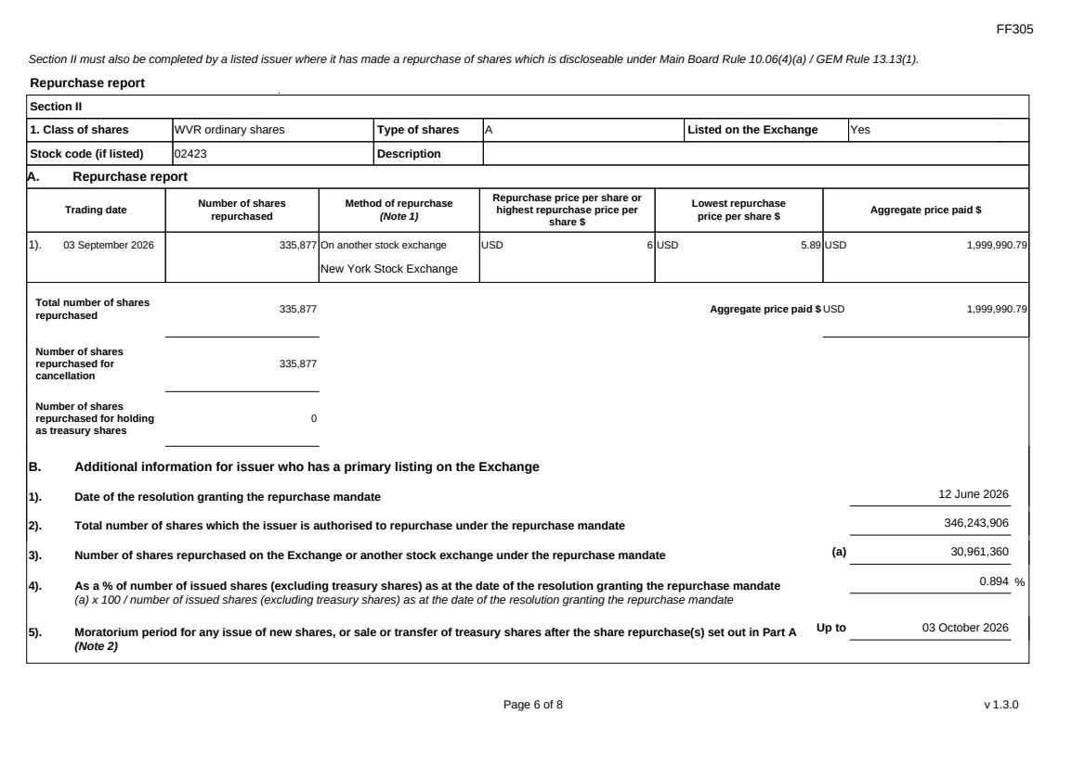 | FF305 Page 6 of 8 v 1.3.0 Section II must also be completed by a listed issuer where it has made a repurchase of shares which is discloseable under Main Board Rule 10.06(4)(a) / GEM Rule 13.13(1). - they carry the same rights as to unrestricted transfer, attendance and voting at meetings and Repurchase report Section II 1. Class of shares WVR ordinary shares Type of shares A Listed on the Exchange Yes Stock code (if listed) 02423 Description A. Repurchase report Trading date Number of shares repurchased Method of repurchase (Note 1) Repurchase price per share or highest repurchase price per share $ Lowest repurchase price per share $ Aggregate price paid $ 1). 03 September 2026 335,877 On another stock exchange New York Stock Exchange USD 6 USD 5.89 USD 1,999,990.79 Total number of shares repurchased 335,877 Aggregate price paid $ USD 1,999,990.79 Number of shares repurchased for cancellation 335,877 Number of shares repurchased for holding as treasury shares 0 B. Additional information for issuer who has a primary listing on the Exchange 1). Date of the resolution granting the repurchase mandate 12 June 2026 2). Total number of shares which the issuer is authorised to repurchase under the repurchase mandate 346,243,906 3). Number of shares repurchased on the Exchange or another stock exchange under the repurchase mandate (a) 30,961,360 4). As a % of number of issued shares (excluding treasury shares) as at the date of the resolution granting the repurchase mandate (a) x 100 / number of issued shares (excluding treasury shares) as at the date of the resolution granting the repurchase mandate 0.894 % 5). Moratorium period for any issue of new shares, or sale or transfer of treasury shares after the share repurchase(s) set out in Part A (Note 2) Up to 03 October 2026
FF305 Page 7 of 8 v 1.3.0 We hereby confirm that the repurchases made on the another stock exchange set out in Part A above were made in accordance with the Main Board Rules and that there have been no material changes to the particulars contained in the Explanatory Statement dated 24 April 2026 which has been filed with the Exchange. We also confirm that any repurchases made on another stock exchange set out in Part A above were made in accordance with the domestic rules applying to repurchases on that other stock exchange. Notes to Section II: 1. Please state whether the repurchase was made on the Exchange, on another stock exchange (stating the name of the exchange), by private arrangement or by general offer. 2. Subject to the carve-out set out in Main Board Rule 10.06(3)(a)/ GEM Rule 13.12, an issuer may not (i) make a new issue of shares, or a sale or transfer of any treasury shares; or (ii) announce a proposed new issue of shares, or a sale or transfer of any treasury shares, for a period of 30 days after any purchase by it of shares, whether on the Exchange or otherwise, without the prior approval of the Exchange.
FF305 Page 8 of 8 v 1.3.0 Section III must also be completed by a listed issuer where it has made a sale of treasury shares on the Exchange or any other stock exchange on which the issuer is listed which is discloseable under Main Board Rule 10.06B / GEM Rule 13.14B. Report of on-market sale of treasury shares Not applicable Submitted by: Siting Li (Name) Title: Joint Company Secretary (Director, Secretary or other Duly Authorised Officer)

